Accounting for Everyone

12 Session Bookkeeping Course

(IRS is not yet included)

Quentin Pain

© Quentin Pain, All rights reserved

DISCLAIMER
The information contained in this book has been produced in good faith the publisher and author cannot accept any responsibility or liability for the information contained in this book howsoever it may be used.

Contents
Introduction 4
Session 1 Accounts 7
Session 2 Equity 14
Session 3 Transactions 21
Session 4 The Ledger 27
Session 5 The T Account 33
Session 6 Patterns 40
Session 7 Profit and Loss Account 55
Session 8 The Balance Sheet 70
Session 9 Stock 83
Session 10 Depreciation and Amortisation 96
Session 11 VAT, Sales Tax, GST and all forms of goods, services, sales and purchase taxes 107
Session 12 Where Do We Go From Here? 123
Business Accountz Trial: Task Answers 124
Incomplete Records System (IRS) Trial: Task Answers 155

Introduction
Welcome to Quentin Pain's world of bookkeeping made easy!
Your decision to get this content-packed, easy to follow bookkeeping course was a wise one. You now own a world class resource containing everything you need to know to become a great bookkeeper.
Our aim is to help you to make sense of accounting. This course is a unique resource and through following the sessions and doing the tasks suggested you will be able to benefit from learning his key strategies.
Over the years through countless discussions with business owners on the ground we kept coming across one killer problem: most people do not understand the financial aspects of their business.
As Quentin says:
‘People who run their own businesses find great difficulty with these three points:
- Business finances and the flow of money
- Accountancy speak and jargon
- Loans and how to talk with your bank'
He researched the available books on the subject to see if there was anything he could recommend but everything he read was written from an academic viewpoint. He found that the resources out there were not aimed at ordinary business owners in the real world struggling to hold their businesses together. As Quentin adds 'Theory is all very well but out there in the hurly burly of actual business life it’s different. So I decided to do something about it.' He wrote Accounting for Everyone and in it he showed us a simple way to understand accounting and the jargon.
One of his brilliant yet crystal clear strategies is to take some really common technical accounting terms and put them into plain English. For instance, he changed accounting jargon ‘Credit’ and ‘Debit’ into ‘From’ and ‘To’. If you think of your accounts as money moving from somewhere (e.g. you sell something so money comes From a Sales Account) to somewhere else (the money gets paid in To your Bank Account) it makes it really clear in your books. And that’s double entry! So you are able to see at a glance exactly what is happening within your business.
Throughout the course technical terms, just as in the example above, that can stop you in your tracks, are covered and explained using everyday language. The course uses worked examples to help you truly understand what you are doing when you are bookkeeping and accounting for a business.
Once you know what a term like Debit really means you can begin to apply it in a useful way. Soon you’ll be talking like a bookkeeper and more importantly you will also know exactly what you mean!
The Accounting For Everyone 12 Session bookkeeping course is designed to be completed on paper (but see page 163 for free trial software). Within this book are pages with blank work sheets to help you to do just that.
This manual has been included with ACAS IRS as it is a very helpful guide regardless of the software illustrated, and has a direct relationship to IRS usage although some terms may differ.

Brief overview of the course
The course starts by covering what an ‘account’ is. Assets and Liabilities are explained along with Equity. Along the way you are introduced to some key concepts such as: accounting is all about the flow of money, where it came from and where it went to.
You will learn all about transactions, posting and ledgers and what these words actually mean in everyday language.
Next we go through T accounts, explore how to do a trial balance and we learn about the Balance Sheet. Everything is explained in clear terms so you can see why these types of report are of interest in your business.
The course also goes into detail about Profit & Loss and also stock and how to make sure it appears correctly in your books.
There's a section on VAT and taxes around the world (including Sales Tax in the USA).
Throughout the course Quentin also offers help on how information is set out in formal bookkeeping exams. Key concepts are included and explained every Session and tasks help you to get a good grounding in all the necessary basics. By the end of the course you will be amazed at your knowledge. Read on and enjoy ☺

Session 1 Accounts
Everything is an account! It is the single most important thing to understand in accounting. Forget categories, sub-categories, classes and any of the other terms you may have heard. Later you will understand why, but for now it is enough to know that we have already simplified double-entry accounting: Everything is an Account. Period.
So, what exactly is an account? It is a way of tracking money. Examples we all know are bank accounts, credit card accounts, deposit accounts etc. If a business has a fleet of vehicles they will almost certainly open a diesel or petrol account at their local garage. But for the rest of us, we rarely think of an expense like ‘petrol’ as an ‘account’. But that’s the point. In the world of accounting, everything is an account, whether it is the a bank, petrol, sales, loan, VAT, depreciation, stationery, telephone, rent, profit and loss etc. They are all accounts.
The second most important thing to understand is that there are no special accounts. Every account does the same thing. It records the flow of money. There are conventions for naming accounts, for example, accumulated depreciation account (enough to put anyone off!), but once you understand that all accounts are the same, it will really help you get your head around the subject. To summarize:
- Accounts track the flow of money
- Accounts have a meaningful name
- Accounts have a balance (which shows how much we have, how much we owe, how much we have spent, how much we have earned etc.)
So, what do we do with these accounts? First we need a place to show them. And that place is called the Chart of Accounts. It is a list of all the accounts used in a business. A list of accounts is great, but it also needs some structure so it makes a little more sense.

Accounts Structure
The most basic structure of a set of accounts is to group them into assets and liabilities. But before we explore what that means, here is a vital lesson on business: Always remember that there is ‘business’ and there is also the ‘owner of the business’. They are separate entities. There is you, and there is your business. If you become (or are) a bookkeeper or an accountant, the separation is exactly the same: You and your bookkeeping/accounting business. There are 2 reasons you need to understand this:
- (The first reason is a digression, but an important one) If you understand this concept, you can make better business decisions. You can look upon your business as something separate and remove the ‘personal’ side of it. This is a good thing to do. We are not talking about important issues such as customer service here, we are talking about being able to decide whether an investment in the business is good or not for the business. For example, a member of staff is causing issues. If you take it personally, you may not want to deal with it because you like the person. If you understand it is a decision for the good of the business and not yourself, you will almost certainly do the right thing. So what exactly has that got to do with accounting?…
- Accounts are split into groups. The basic groups are assets and liabilities: 10
- Assets are things the business owns (e.g. a vehicle, premises, computer and other equipment).
- Liabilities are things the business owes (e.g. loans, overdrafts, tax). The emphasis here is on the business.
Now, the important bit. The business also owes the owner of the business something. This is called Equity. If you want to see what the business is worth to its owner, look at the equity in the business.
OK. How do we show these groups? The most common way to see them is to look at a balance sheet. And what exactly is a balance sheet? It is a list of accounts split into groups, the most basic of which may consist of Assets, Liabilities and Equity.

Summary
We know that the core element of any bookkeeping/accounting system is an account. We know all accounts are the same (there are no special cases). We know all accounts record the flow of money. We know we need to structure these accounts into groups to represent what the business owns and what it owes.
Task
There are 2 important things to note about an account:
- Its name
- Where it is placed in the account structure
Task 1: Write out a list of accounts. They can be of any type you like, bank, sales, expense. What matters is the name. Give them a name that exactly matches what it is they do. For example, ‘Bank’. As soon as you see the word ‘bank’ you know what it does. In the real world, you may name it after your actual bank (e.g. HSBC or Barclays). Another example is Consultancy Work. Does that mean money you have received from consulting work you have done, or is it an expense for consulting work you have had done for you? Try renaming it Consultancy Sales. It’s all in the name! Hint: if you are already in business, just look at all the things that either cost you money, that you receive money for doing, where you store your money or where you get money from. These are your accounts.
Task 2: Structure your accounts into Assets and Liabilities (forget Equity for the moment, Equity is just another liability of the business).

Session 1: Blank for your answer: Task 1

Session 1: Blank for your answer: Task 2

Session 1: Answers to Tasks 1 and 2
There is no definitive answer as accounts can be named anything you like and can be placed anywhere you like within the simple structure of Assets and Liabilities. This is because any account can have a positive or a negative balance.
So, to recap, assets are things the business owns and liabilities are things the business owes. Let’s take a bank account. Whilst it has a positive balance, it is an asset. However, if it should go into the red (it becomes overdrawn) then it is a liability!
So, what to do! Some accounts are simple to place. For example a loan such as a mortgage. We can say with 99% surety that this is a liability (although if you were to pay off more than you owe, then it becomes an asset!). What about a building? Now that is for sure, an asset. So, common sense is required to decide whether an account is more likely to have a positive balance than a negative one.

Let’s take a look at a simple list of accounts split into assets and liabilities:
- Assets
- Bank
- Cash
- Deposit/Savings
- Business Premises
- Equipment Used In Business
- Stock Bought For Resale
- Unpaid Invoices
- Liabilities
- Mortgage
- Loan
- Credit Card
- Unpaid Bills
Notice one thing that is missing from these accounts? Yes, sales and expenses. The whole point of the business. Sales and expense accounts are part of what determines your interest in the business. And that is what the Equity section we briefly mentioned earlier is for.

Session 2 Equity
There are 3 important ingredients of the equity group:
- Profit and Loss Account
- Retained Earnings
- Capital Introduced
At this point we are only interested in the Profit and Loss Account. An interesting thing to note, even at this early stage of this course, is that the Profit and Loss is just another account. It is a long standing misconception that it is some kind of ‘report’. Yes, you can make a lovely looking report from the balances that make up your profit and loss account, and charge for that process, but to really understand accounting, you need to realise that, as said right at the start ‘Everything is an Account’.
The Profit and Loss Account is usually made up from the balances of other accounts. This is where the idea that it is a report comes from. But let’s take a look at this in detail. Here’s the rule: Any account can contain other accounts. To make the distinction between a single account and one that contains other accounts, we will call the latter an Account Group, or Group for short.
As you have seen, Assets and Liabilities are both groups. Equity is also a group. Profit and Loss (aka P&L) is a group. And in turn, the P&L also can contain groups. And that is where we are going right now. The heart of the business. The single most important part of your chart of accounts is the P&L.

Sales and Expense Accounts
Every business needs to analyse its sales. You can do that with a single Sales Account, or you can break that analysis down into as many sales accounts as you need. If you have different segments within your business, you can set up sales groups that contain individual sales accounts.
The exact same applies to expenses. You could have just a single expense account to cover everything, or break expenses into many different accounts (and account groups).
So, what’s the point of bookkeeping and why do we need to use accounts and account groups? There are only 2 reasons:
1. Keeping the Inland Revenue Service happy
2. Managing your business
The Inland Revenue is only interested in your sales (and the tax you will pay on them) and how much you are trying to reduce that tax by submitting expenses. Although in some tax regimes, tax returns contain boxes for different types of expense, all that matters to the revenue is ‘are those expenses real expenses?’ So, the most basic of accounts can contain a single Sales Account and a single Expense Account.
However, the second reason for bookkeeping is by far the most important. Managing your business. You need to breakdown your accounts in as much detail as possible. That way you can track exactly which aspects of your business make money, and which aspects cost you the most. From there you can make the right management decisions that will make your business more profitable.

So let’s take a look at the P&L account group and the accounts it could contain:
- Equity
- Profit and Loss Account Group
  - Sales Account Group
    - General Sales Account
    - Consultancy Sales Account
    - Other Income Account
- Expense Account Group
- General Expense Account Group
- Rent and Rates
- Stationery
- Utility Expense Account Group
- Mortgage Interest
- Telephone
- Internet
- Gas and Electricity
- Rent and Rates
- Water
- Other Expense Account
This is a very general breakdown. You may want to breakdown your sales and expenses in far more detail. The more detail you have the more you will be in control of, and understand, your business.

The Accounting Equation

Assets = Liabilities + Equity

We are moving rapidly into tricky territory here, but stick with it. It is worth it. The point of the double-entry system is that things must balance. What comes in must balance with what goes out. It is all about the flow of money. If you add an asset, then there must be a liability. Hence the accounting equation. Equity is also a liability. Why? because it is what the business owes the owners of that business. The money generated in a business comes from sales. And sales are held in the P&L account. The P&L account is held in Equity. Hopefully that makes sense. You help your business generate sales, therefore the business owes you!
Remember:
- Assets are what the business owns (not you, but the business)
- Liabilities are what the business owes to third parties (eg. suppliers, Inland Revenue etc.)
- Equity is what the business owes its owners (eg. you)
To help you remember this all important equation. Change it to the acronym ALE. Whenever you think of bookkeeping, think of sipping a cold beverage on a hot summers day.
The way to really get to grips with this, however, is to move on to the other main ingredient in a set of books: Transactions. But that is for the next instalment.

Task
This task is slightly tougher (the answer is shown below). You have just started a business and you have injected some money into it. You have deposited the money into the business bank account. So, we know where the money went to (the bank), the question is, where did it come from? Your task is to name that account, then place it in one of the main account groups (assets, liabilities or equity). Remember: accounting is all about the flow of money, where it came from and where it went to.

Session 2: Blank for your answer

Session 2: Answer to the task
The account name: How about ‘Money I Put Into My Business’. And the account group? It’s Equity of course. Equity is what the business owes its owners (you). Well done if you got that right. As to the name of the account (Money I Put… etc), well, it could be anything you like as long as it makes sense to you. However, there are conventional names for this. A typical example is Capital Introduced. If this was a limited company, then it may be called Shareholders Capital or a variety of other names. Remember there are no laws on account naming, only conventions. Choose a name that means something to you. That way you can explain it to anyone who needs to know.
So to summarise, the money in this transaction came from Capital Introduced and went to Bank. And that leads us nicely on to our first transactions and exactly how and what the terms credit and debit mean.

Session 3 Transactions
Every transaction involves 2 accounts and sometimes more. However, thinking in terms of every transaction involving just 2 accounts will really help you understand the logic of double-entry.
A transaction is a recording of the flow of money between 2 accounts. It shows where the money came from and where it went to. It is this from and to concept that the term double-entry refers to. You can think of it as 2 entries = 1 transaction. Each entry affects 1 account. So, 2 entries = 2 accounts = 1 transaction.
Let’s take a look at a typical set of accounts written in an off-the-shelf analysis book available from most stationers. Note we have deliberately reduced the number of columns to keep it simple:

Date | Bank | Cash | Rent | Other expenses
xx.xx.xxxx | 100 |  | 100

It may not be obvious at first, but there are 2 accounts here: Bank and Rent. We know the amount is 100 and we know it took place on such and such a date.
Let’s look at how that transaction would appear in a traditional double-entry system using something called a Journal.

Date | Account | Debit | Credit
xx.xx.xxxx | Rent | 100
xx.xx.xxxx | Bank |  | 100

A Journal is exactly what it says. Somewhere to record something. Many bookkeepers and accountants refer to ‘a journal’ as the actual entry itself, which is fine, but it is important that you understand it is also the name of the book that you write entries in to.
There are many other names for ‘journals’. Day books, cash book, sales book and many more. But they all do the same thing: record day to day transactions.
In practice, you will find most people think of the journal as a special place. Somewhere where you record things that don’t obviously go into any other book. For example, if you make a sale you may record it in your day book. If you receive some money from a customer, it may go into your cash book. But if you later find you have made a mistake somewhere, an accountant or bookkeeper will immediately refer to making a journal to reverse and correct it.
Ultimately, it makes no difference what you call these things. They are simply books that you record transactions in. So you could have a ‘cash book journal, a ‘day book journal’, a ‘general journal’ etc.
Credits and Debits
This next section is the most important in this book. Understand this part, and you will have no problem with debits and credits in the future. And the great part is, it is really, really simple, provided you use our simple memory aid. Keep reading…
Remember that a transaction records the flow of money, from somewhere to somewhere else. The somewheres are accounts. Let’s look at our first transaction again, but transformed slightly. There are 3 steps to this transformation. Don’t worry you will not have to do this every time you try to understand what’s going on. This is just a way to help you see the logic of double-entry. Stay with it:
Step 1
Date | Debit | Credit | Amount
xx.xx.xxxx | Rent | Bank | 100

Look carefully at step 1. The debit and credit columns now contain an account instead of an amount.
Step 2
Date | To | From | Amount
xx.xx.xxxx | Rent | Bank | 100

In step 2 we replace the words debit and credit with to and from.
Step 3
Date | From | To | Amount
xx.xx.xxxx | Bank | Rent | 100

This is the big one. In step 3 we swap the debit and credit columns around. This makes the flow of money much simpler to follow. We are tracking the flow from somewhere to somewhere else. For Western eyes, reading from left to right, top to bottom is natural. When we describe pretty much any type of ‘journey’ in real life, it is always from somewhere to somewhere else. We never say “I went to work from home”.
So, what matters is how to remember how to convert credit and debit to from and to. And here’s the trick: alphabetically, Credit is before Debit. And it just so happens, that From is also before To. So:
Credit = From
Debit = To
Whether you follow any of the above does not matter too much. What is vital to passing any bookkeeping exam, reducing bookkeeping mistakes to the minimum, or simply carrying out a task such as entering a transaction, is to remember:
- The flow of money
- Credit = From
- Debit = To

Tasks
There are five tasks in this section. In the first two you will see the transaction in journal format. Your job is to transform them into our new simpler format. The remaining three tasks are there for you to create both tables. This will greatly help you understand debits and credits, how they look in traditional form, and how they look when transformed into something more logical. In the future, for bookkeeping exams, or when using a traditional system, you will apply this in reverse. That is, you will start with some document (e.g. a sales invoice), transform that into our new from/to nomenclature, then apply our simple rule, and hey presto, you will get your double-entries spot on. This is truly double-entry made simple.
Task 1:
You sell 1,000 worth of goods for cash. We need 2 accounts to record this. One of them is obvious: Cash. The other we shall call Sales. Here’s the transaction in journal form:
Date | Account | Debit | Credit
xx.xx.xxxx | Cash | 1000
xx.xx.xxxx | Sales |  | 1000

Task 2:
You sell 500 worth of goods on credit (the customer has not yet paid you). You will need a new account, which is conventionally called Debtors.
Date | Account | Debit | Credit
xx.xx.xxxx | Debitors (Unpaid Invoices) | 500
xx.xx.xxxx | Sales |  | 500

Task 3:
You sell consultancy time for 300 which is paid direct to your bank. You will need a new account called Consultancy.
Task 4:
You pay 60 for Fuel from your Bank. You will need a Fuel account.
Task 5:
You pay off 600 from your bank to your credit card. You will need a Credit Card account.
Session 3: Blank for your answers
Session 3: Task 1 answer:
Date | From / Credit | To / Debit | Amount
xx.xx.xxxx

Session 3: Task 2 answer:
Date | From / Credit | To / Debit | Amount
xx.xx.xxxx

Session 3: Task 3 answer:
Date | From / Credit | To / Debit | Amount
xx.xx.xxxx

Session 3: Task 4 answer:
Date | From / Credit | To / Debit | Amount
xx.xx.xxxx

Session 3: Task 5 answer:
Date | From / Credit | To / Debit | Amount
xx.xx.xxxx

Session 3: Answers to the tasks
Session 3: Task 1 answer:
Date | From / Credit | To / Debit | Amount
xx.xx.xxxx | Sales | Bank | 1000

Session 3: Task 2 answer:
Date | From / Credit | To / Debit | Amount
xx.xx.xxxx | Sales | Debtors (Unpaid Invoices | 500

Session 3: Task 3 answer:
Date | From / Credit | To / Debit | Amount
xx.xx.xxxx | Consultancy | Bank | 300

Session 3: Task 4 answer:
Date | From / Credit | To / Debit | Amount
xx.xx.xxxx | Bank | Fuel | 60

Session 3: Task 5 answer:
Date | From / Credit | To / Debit | Amount
xx.xx.xxxx | Bank | Credit Card | 600

Get the from/to credit/debit concept fixed in your mind and you will be able to figure out almost all transactions using logic. This is one of the most important things you will learn in order to pass any type of bookkeeping exam, or accurately record transactions in traditional bookkeeping and accounting books or software.

Session 4 The Ledger
So far we have looked at places to record day to day transactions. These are day books, journals and a host of other names, but they all do the same thing: you record what is happening. And you record it chronologically. One transaction after another in date order, regardless of account.
The Ledger is just another book in the accounting system. But there is one important difference. It takes all your day book entries, and re-orders them by account. Yes, everything is recorded twice! Once in the journal, then once again in the ledger. That, by the way has nothing to do with the term double-entry. Remember, double-entry means recording the from/to credit/debit aspect of a transaction.
The entries from our daybooks or journals get into the ledgers via the system of posting. So we say we ‘post a journal to the ledger’. And why exactly do we go to all the bother of doing all the work again? Simple, once reordered by account, we will be able to work out the balance of each account. And that is at the core of why we keep books in the first place. To report to the Inland Revenue and the business owners.
We can see whether we are making a profit or loss. We can see how much money has been invested. We can find out how much money is owed by our customers (Debtors), and we can see how much we owe our suppliers (Creditors). In short, we will get the full picture and a feel or understanding of the finances of the business.
A ledger consists of all the accounts in a system. There may also be sub-ledgers. The balance of the sub-ledgers will be recorded in the main ledger. For example, a typical system will comprise of the following:
- General Ledger (or Nominal Ledger
- Sales Ledger (or Accounts Receivable) (sub-ledger
- Purchase Ledger (or Accounts Payable) (sub-ledger)
The general ledger contains everything we need in order to complete a set of books either for management reports or for tax period ends. So let’s take a look at an account and how it looks in the ledger (nb. there are other formats, most notably the ‘T’ account, covered later). This example is the simplest form and misses out important columns such as transaction numbers and references, but that is so you can appreciate exactly what it does:

BANK
Date | Debit | Credit
xx.xx.xxxx | 500
xx.xx.xxxx |  | 50
xx.xx.xxxx |  | 225

All your accounts have the same format. If you add up all the debits and all the credits, and subtract one from the other, you end up with the balance for that account:
BANK
Date | Debit | Credit
xx.xx.xxxx | 500
xx.xx.xxxx |  | 50
xx.xx.xxxx |  | 225
Sum columns | 500 | 275
Balance | 225

We can see that this account (BANK) has a debit balance of 225 (we have used a simple method to balance this account, balancing is covered in detail in the next part). For a trained bookkeeper or accountant, they now know exactly what a debit balance means. But to a layperson, you can only guess whether that means the account has a positive balance, or is overdrawn, right? This is one of the first questions I ask when I am giving a talk to groups of people who are not bookkeepers/accountants. In every case, the majority gets it wrong.
But luckily, we have our little memory aid to help us: Debit = To. Therefore more money has flowed to the bank rather than from it, therefore the account has money in it. If this is your bank account shown in your set of books, it is good news!
Posting
So how do we get the journals into the ledger? This is the simplest thing in bookkeeping. It is pure copying. If the journal entry is a debit, then it is also a debit in the ledger. If it is a credit in the journal, it is a credit in the ledger. You are literally going to copy every entry in the journal directly into its relevant account in the ledger. Same date, same credit/debit column, same reference etc.
Up until software came along, that is what every bookkeeper did. It was open to error on a massive scale, so safeguards were put in place in order to ensure some kind of accuracy or checking. The most important of these is called the Trial Balance (covered in detail shortly). But the basic concept of recording the flow of money from somewhere to somewhere else, remains the best checking system. If the from and to sides, the credits and debits do not add up (when looking at all the accounts in a system), then there is an error.
Imagine a system where you only recorded one side. Say, a sale. Great. You would know whether you were making a profit or not, but you would have no idea how much you were owed or whether you had any money in the bank. Think of that as single entry. Hopefully, you can now appreciate why double-entry is the world standard, and why it has been around for 600 years.
A ledger consists of a table for each account. Each table contains the account name followed by as many rows as necessary to show all the individual entries for that account. Here’s an example shown in a single table so you get the idea of a single ledger showing all accounts. Extra rows will be required when we come to balance each account, but that is for later:

Date / Account | Debit | Credit
Bank
xx.xx.xxxx | 100
xx.xx.xxxx |  | 50
Sales
xx.xx.xxxx |  | 150
xx.xx.xxxx |  | 200
xx.xx.xxxx |  | 50
Expense
xx.xx.xxxx | 75

Task
Using the five answers from the previous task (the answers to Session 3), post all the entries into the ledger.
You will need to draw up a table and convert them into proper journal entries, but you should have that from your working sheet from the last task. The first two are already prepared in that format from the previous week.
Hint: Start from the first answer. Make sure you record both sides of the transaction. Do not skip. Go from left to right, top to bottom. The most common mistake when posting is to concentrate on just one account at first.
Session 4: Blank for your answer
Date / Account | Debit | Credit
Sales
xx.xx.xxxx
xx.xx.xxxx
Bank
xx.xx.xxxx
xx.xx.xxxx
xx.xx.xxxx
xx.xx.xxxx
Debtors
xx.xx.xxxx
Consultancy
xx.xx.xxxx
Fuel
xx.xx.xxxx
Credit Card
xx.xx.xxxx

Session 4: Answer to the task
Date / Account | Debit | Credit
Sales
xx.xx.xxxx |  | 1000
xx.xx.xxxx |  | 500
Bank
xx.xx.xxxx | 1000
xx.xx.xxxx | 300
xx.xx.xxxx |  | 60
xx.xx.xxxx |  | 600
Debtors
xx.xx.xxxx | 500
Consultancy
xx.xx.xxxx |  | 300
Fuel
xx.xx.xxxx | 60
Credit Card
xx.xx.xxxx | 600

Session 5 The T Account
The traditional way of displaying an account is called the T account. Let’s do this with the Bank account we have created so far during this course. We are also showing in this table the easiest way to balance an account. However, many bookkeeping institutions use a slightly different method for their manually written exams (shown next). The Details column is a memo showing the other side of a transaction. Typically you would also enter a reference number and any other identifying text to make it clear what this transaction was for.

BANK ACCOUNT (using simple balancing method)
Date | Details | Debit (to) |  | Date | Details | Credit (from)
xx.xx.xxxx | Sales | 1000 |  | xx.xx.xxxx | Fuel | 60
xx.xx.xxxx | Consultancy | 300 |  | xx.xx.xxxx | Credit Card | 600
Column  Totals |  | 1300 |  |  |  | 600
xx.xx.xxxx | Balance B/D | 640

You can see where the name T account comes from. It is the shape. Debits on the left of the centre of the ‘T’, credits on the right.
Simple Way To Balance An Account
- Add up the two columns and enter the totals in the next row (as shown above)
- Subtract the lower balance away from the other
- Enter the result under the column with the highest balance. In this example it is the debit column.
Note: The Balance B/D will always be positive or zero.

Traditional Way To Balance An Account For Exams
BANK ACCOUNT (using traditional balancing method)
Date | Details | Debit |  | Date | Details | Credit
xx.xx.xxxx | Sales | 1000 |  | xx.xx.xxxx | Fuel | 60
xx.xx.xxxx | Consultancy | 300 |  | xx.xx.xxxx | Credit Card | 600
 |  |  |  |  | Balance C/D | 640
 |  | 1300 |  |  |  | 1300
xx.xx.xxxx | Balance B/D | 640

Key:
- Balance C/D = Balance Carried Down
- Balance B/D = Balance Brought Down
Both methods are shown for a good reason. The first is much simpler and keeps your calculations on the page (adding your debits and credits and placing the result in a new row so that you can subtract them for the result). Use this method if you want to do manual bookkeeping. It is easier to calculate and easier to audit.
Use the second method if you are taking a manual bookkeeping exam. Note that with the second method you will need a scrap of paper with you to write down the column totals and then do the subtraction before you can enter the Balance C/D total.
Note: You will see that the column totals are underlined with a single line. Traditionally this is drawn with a double underline. You must do that in exams. The medium we are showing this on does not have any method for a double underline.
What Does A Balance Mean?
Okay. We know that the bank from the previous example has a debit balance. Does that mean it is positive or negative? All we need do is apply our from/to rule. Debits = To. That means more money has gone to the bank. It’s that simple. We have a positive balance. We have money in the bank.

Let’s look at the fuel account. This time we will show the details column too (and dispense with the visual T indicator).
FUEL
Date | Details | Debit | Date | Details | Credit
xx.xx.xxxx | Bank | 60 | xx.xx.xxxx | Balance C/D | 60
 |  | 60 |  |  | 60
xx.xx.xxxx | Balance | 60

It too, has a debit balance. So we have spent 60 on fuel. The fuel is in our tank right! The other side of this transaction was 60 from the bank. The bank no longer has the money. If it was the only transaction for the bank, the bank would have a credit balance (60 from). The bank would be overdrawn, but we would have fuel.
Now, let’s take a look at a sales account. This is more interesting, but you should understand the concept of the flow of money more clearly after this.
SALES
Date | Details | Debit | Date | Details | Credit
 |  |  | xx.xx.xxxx | Bank | 1000
 |  |  | xx.xx.xxxx | Bank | 500
 | Balance C/D | 1500
 |  | 1500 |  |  | 1500
 |  |  | xx.xx.xxxx | Balance C/D | 1500

It has a credit balance! What does that mean? Are sales overdrawn because more money has come from sales? No. It is the total value of sales. It is ‘negative’ so to speak because we no longer have whatever it is we sold. Instead we have the money for it (the other side of these transactions was that money flowing to the bank as can be seen in the details column).
Go back to the fuel account and look at it again. There we have no money, but we have fuel. With sales, the stuff sold has gone, hence the credit left in its place.
Whether you choose to show accounts in a T format or just in a simple table makes no difference. Either way, you add up the columns, subtract the lesser total from the greater and place the result under the greater total.
Once we have balanced all the accounts in the system, we need a way to verify or check that they are OK. This is called the Trial Balance. Trial means test by the way. You are testing that all your credits equal your debits.
The Trial Balance
This is a list of all accounts in the system together with their balances. If the total of the debit balances exactly equal the total of the credit balances. We can say our books balance. The point of the trial balance is exactly that. To show up any obvious mistakes. What it will not do, however, is show up wrong postings, wrong dates or amounts entered incorrectly on both sides of the books. Those mistakes can be found by bank, cash and credit card reconciliations, covered later.
Let’s look at a trial balance for the accounts used so far.

Account | Debit | Credit
Sales |  | 1500
Bank | 640
Debtors | 500
Consultancy |  | 300
Fuel | 60
Credit Card | 600
Totals | 1800 | 1800

You can see the debits equal the credits. This set of accounts balances. That means we can now go on to produce further accounts such as the profit and loss account. However, you should practise this a little more first, and that is the subject of the next task.

Task
We are going to add five further transactions to our existing accounts. Your task is to enter them into the journal. Post them to the ledger. Rebalance the ledger accounts. Then create a new trial balance. Hint: this will add four new accounts to the system. Name them what you like. Make each name as meaningful as possible, however, you should be aware that the traditional name for one of the new accounts introduced in the fifth transaction is called Creditors (which means unpaid bills, or money the business owes to a supplier). Another common name for this account, especially in software, is Accounts Payable. Another name for the Debtors account is Accounts Receivable. Stick to one set or the other (ie, Debtors and Creditors or Accounts Receivable and Accounts Payable).
- A Sale for 2000 on credit (an unpaid invoice)
- A purchase of equipment for 1000 paid by credit card
- A transfer of 700 from the bank to a deposit account
- A receipt of 500 paid to the bank for an unpaid invoice you issued earlier
- You receive a bill from your stationery supplier for 200 (an unpaid bill) 48

Session 5: Blank for your answer
Account | Debit | Credit
Totals

Session 5: Answer to the task
Account | Debit | Credit
Sales |  | 3500
Bank | 440
Debtors | 2000
Consultancy |  | 300
Fuel | 60
Credit Card |  | 400
Equipment | 1000
Deposit Account | 700
Creditors |  | 200
Stationery | 200
Totals | 4400 | 4400

If you did the task correctly, your debits will equal your credits, and both will add up to 4400. The four new accounts appear at the bottom.
Transactions Recap
Let’s take another look at transactions. But just before we do, let’s get one myth out of the way. There are no different types of transaction! Yes, that’s right. All transactions are the same. They move money from one account to another. And as we said at the beginning, there are no special types of account either. They all record money coming from and going to them.
It is really important that you understand the last paragraph. Once you fully understand that
- an account is an account and there is no ‘special’ account, and
- once you fully understand that a transaction is a transaction and there is no ‘special’ transaction
it will give you the confidence to do the most difficult of tasks.

Session 6 Patterns
The other vital thing to understand is that there are patterns in accounting. You have already encountered the first. The idea of money flowing from (credit) one account to (debit) another. Another pattern we have already seen is balancing credits and debits. If you want to see the balance of an account, all you do is total the two columns and subtract the lesser balance from the greater. If you then add that balance to the lesser total, you make the two columns balance. You then carry that balance down to the opposite column to get the real balance of the account ready to add more transactions.
The Trial Balance (commonly referred to as the abbreviation TB) includes part of the last pattern. The act of balancing both columns. It is called Trial because that is what it is, you are testing the balances. Do they equal each other? What happens if the TB columns do not equal each other? It means you have made a fundamental mistake somewhere. That mistake can be one of the following:
- One side of the TB has been wrongly added up
- Both sides of the TB have been wrongly added up (rare)
- One part of a transaction has a wrongly posted amount
- One part of a transaction has been missed out altogether
- One part of a transaction has been posted on the wrong side 52

The TB balances. Does that mean it is correct?
No! It just means that the debits equal the credits. It does not prove the following:
- A complete transaction or more has been omitted (Omissions)
- An error on one side cancels an error on the other (Commission)
- Amounts miss-posted to the wrong account or accounts (Commission or Principle)
- Amount entered wrongly (but the same wrong amount) on both sides (Commission or Compensating)
- Amounts entered on the side of both accounts (Principle)
Here are the definitions of the types of error (in brackets above):
- Original: Errors in original books
- Omission: Completely missing transaction (or 2 separate compensating sides missed)
- Commission: Wrongly copying something
- Compensating: Two wrongs making a right!
- Principle: Placing an account in the wrong place (eg. expense as capital)
Correcting a balancing TB but with errors of the above types
Where the accounts (and if relevant the amounts) are wrong:
- Copy the original transaction but reverse the accounts involved (thus zeroing the transaction)
- Make a new correct transaction 53
Where the accounts are correct but the amount is wrong:
- Make a transaction compensating for the difference
Correcting an Imbalancing Trial Balance
- For each wrong entry make a reversing entry
- For each reversing entry make the correct entry (except if the reversing entry is the correction)
If there is an amount that you cannot find or correct. Open a suspense account and post it there. A suspense account, like all accounts, is nothing special. It is just a means of temporarily balancing the books. Place the suspense account in current assets or liabilities depending on its balance. Once the correct account is known, it can be zeroed by posting its balance to the correct account.
Profit and Loss Account
Let’s move on to what many people assume is a report, some assume is a special kind of account, and those ‘in the know’ understand is just another account: the Profit and Loss (P&L) account. To see how this can be, let’s forget every other account and place our sales and expense transactions directly in the P&L account. Suppose we have two sales, the first for 100, the second for 40, and three expenses; 25, 45 and 69.
Before we show the P&L account, let’s look at the five transactions, so we can understand their debits and credits. As you know, every transaction involves two accounts. We know that one side of all these transactions will be the P&L. For now, we will assume the other side is Bank.
- From Sales To Bank 100
- From Sales To Bank 40
- From Bank To Expenses 25
- From Bank To Expenses 45
- From Bank To Expenses 69
You can see how easy it is to transpose From instead of Credit and To instead of Debit. It dramatically shows the flow of money. When you first start, think in terms of From and To, then transpose them to Credit and Debit. You will ‘get it’ really fast this way. And better still, you will be able to work out credits and debits with logic.
Top Tip
Alphabetically, Credit is before Debit and From is before To.
Credit = From, Debit = To.
This is how you remember which is a credit and which is a debit. We have all learnt our alphabet, so the hard bit is done for you. Let’s transpose those five transactions:

- Credit Sales Debit Bank 100
- Credit Sales Debit Bank 40
- Credit Bank Debit Expenses 25
- Credit Bank Debit Expenses 45
- Credit Bank Debit Expenses 69
And now let’s write them straight into the P&L account. The date will be the date you compiled this:
Profit and Loss Account
Date | Detail | Debit (to) | Date | Detail | Credit (From)
xx.xx.xxxx | Expenses | 25 | xx.xx.xxxx | Sales | 100
xx.xx.xxxx | Expenses | 45 | xx.xx.xxxx | Sales | 40
xx.xx.xxxx | Expenses | 69
 | Balance C/D | 1
 |  | 140 |  |  | 140
 |  |  | xx.xx.xxxx | Balance B/D | 1

And finally let’s balance the account. As you can see we end up with a credit balance of 1. What does that mean? Let’s translate it into English. More money has come FROM Sales than has gone TO Expenses. We have received more money from sales. Therefore we have made a profit.
If you learnt this any other way, you would need to understand that a credit balance in the P&L account (or indeed in any sales account) meant that we were making money from sales. Let’s look at that from another point of view. Suppose the last expense was 71 instead of 69. We would now have a debit balance. And that would mean that More money had gone TO Expenses than we had received FROM Sales. Or in other words, a loss.
So, how would we compile a P&L account without entering transactions directly in there? Well it is actually extremely easy. We are going to reduce the balances of all our sales and expense accounts to zero and transfer those balances to the P&L account. And how are we going to do that? With more transactions! The point being that there are accounts, and there are transactions. And that is it.

We don’t have to work out how to enter these transactions as all the work is already there. We are going to use the same pattern we used when balancing an account. To keep this simple, we will use just a single Sales account and a single sales transaction for 100 (which goes to the Bank). Here’s the balanced sales account:
SALES
Date | Detail | Debit | Date | Detail | Credit
 | Balance C/D | 100 | xx.xx.xxxx | Bank | 100
 |  | 100 |  |  | 100
 |  |  | xx.xx.xxxx | Balance B/D | 100

But to make this simpler let’s just show the ‘unbalanced’ account. As there is only a single entry, you should see the logic immediately. We are going to remove all the other columns too so you can concentrate on only the accounts and the amounts. Here’s the actual transaction: Debit Bank 100 Credit Sales 100
SALES
Debit | Credit
 | 100

How do we zero the balance? We add a 100 debit, right? The balance will then be zero. Here’s half the transaction: Debit Sales 100
SALES
Debit | Credit
100 | 100

So, we have put in the debit to zero Sales, but where does the other half of this transaction go (the credit)? Direct to the P&L account! Credit P&L 100.
Profit and Loss
Debit | Credit
 | 100

So the transaction was Debit Sales Credit P&L. If you study this, you can see all we have done is move the balance from Sales to the P&L account. At the start the Sales account had a credit balance of 100. At the end the P&L account has a credit balance of 100 and the Sales balance is zero. Three accounts were involved:
- Bank (with a debit balance of 100)
- Sales (with a zero balance)
- Profit and Loss (with a credit balance of 100)
You can see without any effort that a trial balance would show that the books balance (zero balancing accounts are not normally shown in a trial balance by the way).
Trial Balance | Debit | Credit
Bank | 100
Sales |  | 0
Profit and Loss |  | 100
Totals | 100 | 100

One important caveat here. No one traditionally will include the P&L account in a TB. The idea of a TB is to check all the individual accounts, rather than accounts that consist of other accounts. This is to catch mistakes before they have any chance of being compounded further. But you have learnt an important principle here about accounts and what you can do with them.
Read this section a few times. Although it looks like we are doing something special, the reality is we are not. We are just transferring money between two accounts, the same as always. In this example the money is transferred From (Credit) the P&L To (Debit) the Sales account in order to zero it.
There is one question left. Why would we want to zero the Sales account? The answer is that the P&L consists of all the balances in the sales and expense accounts. We do not want to duplicate those balances, so we make transfers like this to ensure that we do not.
If you wanted to see how your business was doing on a monthly basis, you would do this every month. That is how monthly management reports are made.
Many accountants and bookkeepers will not zero the sales and expense accounts until year end, instead preferring to produce a P&L report based on the sales and expense accounts.
But this is still an important lesson on how accounts work. Later sections of this book go into great detail into what happens at the end of the year. You will see that we will also be zeroing the P&L account in that process so that all our revenue accounts are ready for the new year.
Notes:
- If you are wondering about VAT (UK, Eurozone and other countries), Sales Tax (USA) or GST (Australia), it is covered in detail later. What matters now is understanding the nature of bookkeeping from a transaction right through to the balance sheet.
- We will also cover Sales and Purchase Ledgers later. Up till now we have looked at all creditors (people the business owes money to) and debtors (people who owe money to the business) as a single unit. Sales and Purchase Ledgers separate these into individual accounts for each customer and supplier.
- We have not looked at discounts, returns and stock bought for resale. Discounts and returns are, for some reason, given great importance in bookkeeping text books, and we will cover them, but there is nothing special about them. Stock bought for resale is also a simple concept and this is covered later too.
- We are only using whole numbers at the moment to make it simpler to add columns. In a real set of books you would be accounting for every penny as you will see later in this course.

Task
This task is not based on any previous tasks. Write up the following transactions directly into T accounts. Balance the T accounts. Create a Trial Balance. Create a Profit and Loss account from the sales and expense accounts.
- A sale for 1000 to the bank
- A purchase of tools to be used in the business for 500 paid by credit card
- A transfer of 200 from the bank to the credit card
- A transfer of 100 from the bank to cash
- An expense of 50 paid by cash
- An expense of 100 on credit
- A sale on credit of 1500
- A purchase of a computer for 400 on credit
- A receipt of 500 from a customer (debtor)
- A payment of 200 to a supplier (creditor)

Session 6: Blank for your answers
T accounts
BANK
Date | Details | Debit | Date | Details | Credit

CASH
Date | Details | Debit | Date | Details | Credit

CREDIT CARD
Date | Details | Debit | Date | Details | Credit

CREDITORS
Date | Details | Debit | Date | Details | Credit

DEBTORS
Date | Details | Debit | Date | Details | Credit

EQUIPMENT
Date | Details | Debit | Date | Details | Credit

EXPENSES
Date | Details | Debit | Date | Details | Credit

SALES
Date | Details | Debit | Date | Details | Credit

Trial Balance
Amount | Debit | Credit

SALES
Date | Details | Debit | Date | Details | Credit

EXPENSES
Date | Details | Debit | Date | Details | Credit

PROFIT AND LOSS ACCOUNT
Date | Details | Debit | Date | Details | Credit
Session 6: Answers to the task
Task answer Trial Balance
Here are the completed and balanced T accounts for the task. The transaction number has been placed in brackets in the details column so you can check where each transaction was posted to. There were 10 transactions, so you should have 20 entries:
BANK
Date | Details | Debit | Date | Details | Credit
xx.xx.xxxx | Sales (1) | 1000 | xx.xx.xxxx | Credit cards (3) | 200
xx.xx.xxxx | Debtors (9) | 500 | xx.xx.xxxx | Cash (4) | 100
 |  |  | xx.xx.xxxx | Creditors (10) | 200
 |  |  |  | Balance C/D | 1000
 |  | 1500 |  |  | 1500
xx.xx.xxxx | Balance B/D | 1000

CASH
Date | Details | Debit | Date | Details | Credit
xx.xx.xxxx | Bank (4) | 100 | xx.xx.xxxx | Expenses (5) | 50
 |  |  |  | Balance C/D | 50
 |  | 100 |  |  | 100
xx.xx.xxxx | Balance | 50

CREDIT CARD
Date | Details | Debit | Date | Details | Credit
xx.xx.xxxx | Bank (3) | 200 | xx.xx.xxxx | Equipment (tools) (2) | 500
 | Balance C/D | 300
 |  | 500 |  |  | 500
 |  |  | xx.xx.xxxx | Balance B/D | 300

CREDITORS
Date | Details | Debit | Date | Details | Credit
xx.xx.xxxx | Bank (10) | 200 | xx.xx.xxxx | Expenses (6) | 100
 | Balance C/D | 300 | xx.xx.xxxx | Equipment (8) | 400
 |  | 500 |  |  | 500
 |  |  | xx.xx.xxxx | Balance B/D | 300

DEBTORS
Date | Details | Debit | Date | Details | Credit
xx.xx.xxxx | Sales (7) | 1500 | xx.xx.xxxx | Bank (9) | 500
 |  |  |  | Balance C/D | 1000
 |  | 1500 |  |  | 1500
xx.xx.xxxx | Balance B/D | 1000

EQUIPMENT
Date | Details | Debit | Date | Details | Credit
xx.xx.xxxx | Credit card (2) | 500
xx.xx.xxxx | Creditors (8) | 400 |  | Balance C/D | 900
 |  | 900 |  |  | 900
xx.xx.xxxx | Balance B/D | 900

EXPENSES
Date | Details | Debit | Date | Details | Credit
xx.xx.xxxx | Cash (5) | 50
xx.xx.xxxx | Creditors (6) | 100 |  | Balance C/D | 150
 |  | 150 |  |  | 150
xx.xx.xxxx | Balance B/D | 150

SALES
Date | Details | Debit | Date | Details | Credit
 |  |  | xx.xx.xxxx | Bank (1) | 1000
 | Balance C/D | 2500 | xx.xx.xxxx | Debtors (7) | 1500
 |  | 2500 |  |  | 2500
 |  |  | xx.xx.xxxx | Balance B/D | 2500

Trial Balance
Amount | Debit | Credit
Bank | 1000
Cash | 50
Credit card |  | 300
Sales |  | 2500
Equipment | 900
Expenses | 150
Debtors | 1000
Creditors |  | 300
 | 3100 | 3100

Two new transactions (numbers 11 and 12) need to be added to the sales and expense accounts to create the profit and loss account:
- Debit Sales Credit Profit and Loss 2500 (11)
- Debit Profit and Loss Credit Expenses 150 (12)
Here are those two accounts updated and balanced. Note that as the balance of each is zero, it is not necessary to add Balance C/D or B/D totals. This is followed by the profit and loss account.
SALES
Date | Details | Debit | Date | Details | Credit
 |  |  | xx.xx.xxxx | Bank (1) | 1000
 | Balance C/D | 2500 | xx.xx.xxxx | Debtors (7) | 1500
 |  | 2500 |  |  | 2500
xx.xx.xxxx | Profit and Loss Account (11) | 2500 | xx.xx.xxxx | Balance B/D | 2500
 |  | 2500 |  |  | 2500

EXPENSES
Date | Details | Debit | Date | Details | Credit
xx.xx.xxxx | Cash (5) | 50
xx.xx.xxxx | Creditors (6) | 100 |  | Balance C/D | 150
 |  | 150 |  |  | 150
xx.xx.xxxx | Balance B/D | 150 | xx.xx.xxxx | Profit and Loss Account (12) | 150
 |  | 150 |  |  | 150

PROFIT AND LOSS ACCOUNT
Date | Details | Debit | Date | Details | Credit
xx.xx.xxxx | Expenses (12) | 150 | xx.xx.xxxx | Sales (11) | 2500
 | Balance C/D | 2350
 |  | 2500 |  |  | 2500
 |  |  | xx.xx.xxxx | Balance B/D | 2350

As you can see we have a credit balance in the P&L account, so it means more money has come FROM sales than has gone TO expenses, therefore we have a profit of 2,350. If you got this result, give yourself a pat on the back. You have come far in a short space of time. If not, don’t worry. Go through this section again. Going from transactions through to the P&L account is about as far as most bookkeepers need to go, so this is the important bit to learn.
Note: We have also balanced off the sales and expense accounts. We are now ready to record more sales and expenses, and when needed, update the P&L account in exactly the same way.

Session 7 Profit and Loss Account
Let’s go into more detail on what else can be shown in the P&L account. So far we have covered the basics: sales and expenses. And as just explained, for most bookkeepers that is the end of it. However, you can go a lot further (and accountants need to). This is because the P&L account, like all things in accountancy, should portray as close a picture to the reality of a business as is possible.
A business consists of assets as you know. Some assets change value in time. For example, tools or other equipment bought for the business will wear out, breakdown, become lost or even stolen. These things will have an impact on the P&L account.
Furthermore, you will pay taxes based on your profit (assuming there is a profit of course). To see the real profit of a business you need to subtract all these things. Let’s take a look at the structure of a P&L account.
We have already covered sales and expenses. To assess the value of assets we take a look at two areas:
- Depreciation
- Amortisation
These are just more accounts in the system. They record the change in value of assets. We will cover these in detail later.
Tax is just the same. More accounts!

So far we have structured the P&L account as a T account. Let’s show another option. This time we will look at it as a report and include all of the main sections so you get a good idea of what exactly a P&L account shows about a business.

Profit and Loss | Total
Sales | 2500
Less Expenses | 150
Less Depreciation | 500
Less Amortization | 600
Less Tax | 200
Net Profit | 1050

Different terminology is used when describing profit, which is also known as Earnings. For example:
- Ebit
- Ebitda
Ebit: Earnings Before Interest and Tax. But includes depreciation and amortization. This is the most common. If you were to move the business to a different country with a different tax regime/rate, this would be just as valid as in the original country.
Ebitda: Earnings Before Interest, Tax, Depreciation and Amortization. This is what we have been doing so far with our P&L account. It is the basics: sales less expenses.
There is one more aspect we need to cover in this section: Cost of Goods Sold.
Cost of Goods Sold
This is a sub-section of the sales area of the P&L. It extracts costs that are directly associated with selling goods from the general expense area and places them with the sales. This is so you can see the real value of your sales. In other words your margin. To understand this a little more, let’s look at three terms:
- Turnover
- Gross Profit
- Net Profit
Turnover is the total value of your sales. If you looked at turnover on its own you would have no idea if a business was any good. For example, whilst a turnover of 1,000,000 may look great, if the direct costs involved in making that million cost a million or more, it would not be a viable business. Ie. if you sold cars at half what they cost you, you would sell out, but you would make a vast loss. This is where Gross Profit comes in.
Gross Profit is your turnover less the direct costs involved in that turnover. If you made cars, an example of a direct cost would be the metal used in making a car. To decide whether something is a direct cost or not, ask this question, could the product itself be made without that cost? You could argue that without a CEO nothing would get made! So you have to use common sense here. For example, take electricity. Some of that expense would be used to light and heat the admin part of a factory. Some would be used to power the machinery to make the car. If you wanted to really account for every single cost involved in car manufacture, then you would apportion some of the electricity costs into the Cost of Goods Sold area. For most businesses, especially smaller businesses, COGS are kept fairly simple, and often only include the really tangible aspects. For example packaging and shipping costs of a product. For example, you could not sell a product without its box and documentation, and you could not sell it without paying to ship it to the customer. Whereas, you could still sell it even if you had a power cut.
Net Profit is exactly what it says. Sales less the cost of those sales (COGS) less all other expenses.
Let’s take a look at a P&L report with COGS included.
Trading and Profit and Loss Account | Total
Sales | 2500
Cost of Goods Sold | 500
Gross Profit | 2000
Expenses | 750
Net Profit | 1250

Notes:
- A COGS section is usually only included if a business manufactures or resells goods. It is rarely used for a services industry though there is nothing to stop you doing this if it makes sense.
- The Sales section and COGS section combined is also referred to as the Trading Account.
Tasks
Task 1 Add the following transactions to the P&L Account we created from last week’s task (ignore the items shown in the Trading account example above). You decide whether these new transactions should go in COGS or Expenses. To do this, you will need to create a new account called COGS. In the real world, you will have a COGS section that, like the P&L Account, include sub-accounts to record the actual things used in the manufacture or selling of goods. Eg. Packaging, Documentation, Shipping. Task 2 asks you to redo task 1 using sub-accounts. All payments are paid direct from the bank.
- Payment of 200 for electricity to run the office
- Payment of 50 for stationery
- Payment of 1,000 for packaging used for the products
- Payment of 60 for diesel used to deliver the products to a distributor
- Payment of 100 to service the company delivery vehicle

Task 2 Rework the above to use individual accounts for the COGS section and post those into a Trading Account.

Task 3 Produce a Trading and Profit and Loss Report of the above tasks.

Session 7: Blank for your answers
Hint: Start by showing the Trial Balance (TB) of just the five transactions from last week:
Trial Balance
Account | Debit | Credit
Totals

BANK
Date | Details | Debit | Date | Details | Credit

ELECTRICITY
Date | Details | Debit | Date | Details | Credit

FUEL
Date | Details | Debit | Date | Details | Credit

PACKAGING
Date | Details | Debit | Date | Details | Credit

SERVICING
Date | Details | Debit | Date | Details | Credit

STATIONERY
Date | Details | Debit | Date | Details | Credit
EXPENSES
Date | Details | Debit | Date | Details | Credit

COGS
Date | Details | Debit | Date | Details | Credit

Answer to task 1: Hint: this task builds on the previous task. So we are adding to the P&L from last week.
PROFIT AND LOSS ACCOUNT
Date | Details | Debit | Date | Details | Credit

Answer to task 2:
COGS
Date | Details | Debit | Date | Details | Credit

TRADING ACCOUNT
Date | Details | Debit | Date | Details | Credit

Answer to task 3:
Trading and Profit and Loss Report for the period xx.xx.xxxx To xx.xx.xxxx | Total

Session 7: Answers to the tasks
Task answer Profit and Loss, COGS and the Trading Account
We are going to start by showing the Trial Balance (TB) of just the five transactions from last week. A TB consists of all the accounts in a set of books that have non-zero balances. However, you can also prepare a TB for a series of transactions if you need to. A transaction is always complete in itself. You cannot have a non-balancing transaction. Transactions are never one sided, therefore creating a TB for one or more transactions is fine if you want to check your work. Until you get used to it, number the elements in a transaction as we have done. It is then easier to spot errors.
Trial Balance
Account | Debit | Credit
Bank (1,2,3,4,5) |  | 1410
Electricity (1) | 200
Fuel (4) | 60
Packaging (3) | 1000
Servicing (5) | 100
Stationery (2) | 50
Totals | 1410 | 1410

Here are the full set of accounts for last week’s task. Note that the bank continues from where we left off from the previous task (a debit balance of 1,000) using the text ‘Balance B/F’, which means Balance Brought Forward (we are bringing it forward from the previous page so to speak).
It does not matter if you did not add the extra accounts or updated the bank but simply posted direct to the P&L for part 1, but if you got stuck, this will help you see the flow.
Where there is just a single transaction in an account, we rule off the line without bothering with a Balance C/D or B/D row. This is simply because there is no balance to bring down.

BANK
Date | Details | Debit | Date | Details | Credit
xx.xx.xxxx | Balance B/F | 1000 | xx.xx.xxxx | Electricity (1) | 200
 |  |  | xx.xx.xxxx | Fuel (4) | 60
 |  |  | xx.xx.xxxx | Packaging (3) | 1000
 |  |  | xx.xx.xxxx | Servicing (5) | 100
 | Balance C/D | 410 | xx.xx.xxxx | Stationery (2) | 50
 |  | 1410 |  |  | 1410
 |  |  | xx.xx.xxxx | Balance B/D | 410

ELECTRICITY
Date | Details | Debit | Date | Details | Credit
xx.xx.xxxx | Bank (1) | 200 | xx.xx.xxxx | Expenses | 200
 |  | 200 |  |  | 200

FUEL
Date | Details | Debit | Date | Details | Credit
xx.xx.xxxx | Bank (4) | 60 | xx.xx.xxxx | Expenses | 60
 |  | 60 |  |  | 60

PACKAGING
Date | Details | Debit | Date | Details | Credit
xx.xx.xxxx | Bank (3) | 1000 | xx.xx.xxxx | COGS | 1000
 |  | 1000 |  |  | 1000

SERVICING
Date | Details | Debit | Date | Details | Credit
xx.xx.xxxx | Bank (5) | 100 | xx.xx.xxxx | Expenses | 100
 |  | 100 |  |  | 100

STATIONERY
Date | Details | Debit | Date | Details | Credit
xx.xx.xxxx | Bank (2) | 50 | xx.xx.xxxx | Expenses | 50
 |  | 50 |  |  | 50

Here’s the resulting Expense and COGS accounts from the above. Five parts of the original transactions have now moved into these two accounts. We have then posted the balances to the P&L account.

EXPENSES
Date | Details | Debit | Date | Details | Credit
xx.xx.xxxx | Electricity (1) | 200
xx.xx.xxxx | Stationery (2) | 50
xx.xx.xxxx | Servicing (5) | 100 |  | Balance C/D | 350
 |  | 350 |  |  | 350
xx.xx.xxxx | Balance B/D | 350 | xx.xx.xxxx | P&L | 350
 |  | 350 |  |  | 350

All the packaging was used to make the sales (as implied in the question) and all the diesel was used to deliver the goods. Hence these are direct costs of the sales. We would not have used the packaging nor consumed the diesel had we not made any sales.
COGS
Date | Details | Debit | Date | Details | Credit
xx.xx.xxxx | Packaging (3) | 1000
xx.xx.xxxx | Fuel (4) | 60 |  | Balance C/D | 1060
 |  | 1060 |  |  | 1060
xx.xx.xxxx | Balance B/D | 1060 | xx.xx.xxxx | P&L | 1060
 |  | 1060 |  |  | 1060

Answer to task 1: Remember that this task builds on the previous task. So we are adding to the P&L from last week.

PROFIT AND LOSS ACCOUNT
Date | Details | Debit | Date | Details | Credit
xx.xx.xxxx | Expenses (12) | 150 | xx.xx.xxxx | Sales (11) | 2500
 | Balance C/D | 2350
 |  | 2500 |  |  | 2500
xx.xx.xxxx | Expenses | 350 | xx.xx.xxxx | Balance B/D | 2350
xx.xx.xxxx | COGS | 1060
 | Balance C/D | 940
 |  | 2350 |  |  | 2350
 |  |  | xx.xx.xxxx | Balance B/D | 940

Answer to task 2: Reworked COGS and the Trading Account. The only difference to the COGS account is the post to the Trading Account (instead of direct to the P&L).
COGS
Date | Details | Debit | Date | Details | Credit
xx.xx.xxxx | Packaging (3) | 1000
xx.xx.xxxx | Fuel (4) | 60 |  | Balance C/D | 1060
 |  | 1060 |  |  | 1060
xx.xx.xxxx | Balance B/D | 1060 | xx.xx.xxxx | P&L | 1060
 |  | 1060 |  |  | 1060

The trading account consists of sales less the cost of those sales.
TRADING ACCOUNT
Date | Details | Debit | Date | Details | Credit
xx.xx.xxxx | COGS | 1060 | xx.xx.xxxx | Sales (from last week) | 2500
 | Balance C/D | 1440
 |  | 2500 |  |  | 2500
 |  |  |  | Balanace B/D | 1440

Answer to task 3: Note that this is a report. We have not posted anything to it, just reported on balances from existing accounts.
Trading and Profit and Loss Report for the period xx.xx.xxxx To xx.xx.xxxx | Total
Sales | 2500
Cost of Goods Sold | 1060
Gross Profit | 1440
Expenses | 500
Net Profit | 940

This task was difficult. Don’t worry if you struggled. You are taking in a lot of information very quickly. Please read through it again:

Session 8 The Balance Sheet
The balance sheet is where the accounts are consolidated and summarised into something meaningful as a snapshot of the business. It is only as good as the day it was compiled. It shows no date range or period of time. Just the balances of the business on a specific date.
Compare that to the P&L account. The P&L covers a period of time (assuming there was more than one transaction and they did not occur simultaneously!). The point being that if you want to see how healthy a business is, you will need to see a series of balance sheets. And that leads us on nicely as to why a balance sheet is useful. There are 2 main reasons:
- For tax (Inland Revenue)
- For management
The latter is of course the most important reason. If business owners did not start businesses that were profitable there would be no Inland Revenue service (nor government for that matter) as there would be no money to run them!
There is no ‘right’ balance sheet! Yes, a balance sheet must ‘balance’, but that is not what we mean by ‘right’. Let’s go back to basics. In particular, the accounting equation that we explained in part 2. Remember there are 3 core parts:
- Assets (what the business owns)
- Liabilities (what the business owes third parties)
- Equity (what the business owes its owners)
That is all we need to show in a balance sheet. The sum total of those parts. But of course, that would be next to useless (eg. 2=1+1). We could also show every individual account in the balance sheet. That would be far more useful, but very hard to read. Take the P&L Account for example. We produce it for 2 main reasons:
- To consolidate or summarise some of our accounts
- To view the overall balance (are we making a profit or loss)
So that is a great place to start our balance sheet. We have summarised the P&L down to a single balance, and if you remember, that balance is included in the Equity section. So, what of the assets?

Assets
Assets are generally broken down into two main groups:
- Current Assets
- Fixed Assets
You are going to see a pattern here, and this will really help you understand that in bookkeeping and accounting, there are only a few patterns, and they repeat all over the place. The P&L Account is made up of sub-accounts. Well, guess what? So are current and fixed assets. We could if we wanted to, zero all these off and post them to a Current Assets Account (and a Fixed Assets Account). Whether you choose to do that or not does not matter. It is the principle that is important as you will see.
Current Assets
What are current assets? The simple answer is that they are accounts that fall due or can be converted to cash within a year. Simple examples are bank and cash accounts. Another example is Accounts Receivable (aka Trade Debtors, or ‘Money Owed To The Business’). Unless you have some special terms, most businesses selling on credit will want that credit paid within, say, 30 days. This makes Accounts Receivable a perfect candidate for a Current Asset. Another common example is Stock or Materials Bought. These track items bought for resale or items bought in order to make into items for resale (ie. manufacturing). In theory, as you have bought these items, you should equally be able to sell them again as they are. So, another good candidate for our Current Asset list.
Current assets are also known as liquid assets. Liquid is a way to describe just how fast an account can be turned into cash. Usually, current asset accounts are ordered by their liquidity, the most liquid at the top (eg. cash and bank).
Fixed Assets
Fixed assets are for items that do not fall due within a year. They are also for items that you buy for the business that you do not intend to sell within a year. Typical examples are company vehicles and buildings. Another good example is equipment bought for use in the business. This could be furniture and other fittings of an office or shop, computer and other IT equipment, tools used for a trade, and investments.

Liabilities
Liabilities are also broken down into two main groups:
- Current Liabilities
- Long Term Liabilities
Liabilities have the same pattern as assets.
Current Liabilities
These are things the business owes that fall due within one year. This could include short term loans such as a bank overdraft. Another great example is a company credit card. If you buy things on credit, then exactly like selling on credit, terms are usually around 30 days, so Accounts Payable (aka Trade Creditors or ‘Money Owed To Suppliers’) is included as a current liability.
Long Term Liabilities
This is for money borrowed on a long term basis (ie. longer than a year). Typical accounts will be a bank loan (assuming it is not a short term one of course). A mortgage account for a company building is also a typical example as would be a lease for a company vehicle.

Layout
A balance sheet can be laid out vertically or horizontally. There is very little difference between them. All that matters is that it is readable. The horizontal layout is the layout you should be very familiar with by now. Debits on the left, credits on the right. Here is a very simple layout. Note: the bank has a credit balance, but we are showing it in the Debit column. The convention is to put brackets round it to show the balance is negative. Sometimes it is useful to leave an account in its expected place on the balance sheet.
Balance Sheet as on xx.xx.xxxx
Assets | Debit balances | Liabilities | Credit Balances
Bank | (410) | Credit card | 300
Cash | 50 | Creditors | 300
Debtors | 1000
Equipment | 900
 |  | Equity
 |  | P&L | 940
Totals | 1540 |  | 1540

Remember the accounting equation shown in part 2:
- Assets = Liabilities + Equity (ALE is the acronym to help you remember)
As you can see above, this balance sheet balances. Another form of the accounting equation is to place equity on its own:
- Equity = Assets – Liabilities
This is more common as it places the emphasis on the owner’s equity (money) in the business, however the first version is easier to remember and there are no negative operators in there.

On to the far more common vertical layout:
Balance Sheet as on xx.xx.xxxx
Assets
Bank | (410)
Cash | 50
Debtors | 1000
Equipment | 900
Total Assets | 1540
Liabilities
Credit card | 300
Creditors | 300
Total Liabilities | 600
Total Assets less Liabilities |  | 940
Equity
P&L | 940
Total Equity | 940 | 940

Tasks
Task 1 Add the following transactions and post to our current set of accounts (the accounts we have used in weeks 6 and 7 as finalised in the balance sheet above).
- Buy 500 worth of materials on credit for use in future manufacturing
- Buy 200 worth of stock on credit to put in your shop for resale
- Receive 1000 for consultancy work (paid direct to the bank)
- Transfer 50 from bank to cash
Task 2 Update the P&L Account
Task 3 Prepare a vertical balance sheet

Session 8: Blank for your answers
Answer to task 1:
BANK
Date | Details | Debit | Date | Details | Credit

CASH
Date | Details | Debit | Date | Details | Credit

CREDITORS
Date | Details | Debit | Date | Details | Credit

CONSULTANCY
Date | Details | Debit | Date | Details | Credit

MATERIALS
Date | Details | Debit | Date | Details | Credit

STOCK
Date | Details | Debit | Date | Details | Credit

Answer to task 2:
PROFIT AND LOSS ACCOUNT
Date | Details | Debit | Date | Details | Credit

Hint: you could use this table to do a test TB to ensure everything is as it should be (not obligatory – all should become clear when you check your answers!)
Account | Debit | Credit

Answer to task 3: Vertical balance sheet
Balance Sheet as on xx.xx.xxxx

Session 8: Answers to the Tasks
We will need 3 new accounts for this task:
- Materials
- Stock
- Consultancy (or using the existing Sales account is fine)
We also need the existing Bank, Cash and Creditors accounts as they need updating.
Answer to task 1: updating and adding the new accounts
BANK
Date | Details | Debit | Date | Details | Credit
xx.xx.xxxx | Consultancy (3) | 1000 | xx.xx.xxxx | Balance C/F | 410
 |  |  | xx.xx.xxxx | Cash (4) | 50
 |  |  |  | Balance C/D | 540
 |  | 1000 |  |  | 1000
xx.xx.xxxx | Balance B/D | 540

We included transaction 4 for a specific reason. It is an example of a Contra transaction. When you move money from one account to another but both accounts are in the same group (current assets in this case) it is called a contra transaction. This is really an irrelevant term in the real world (it is just another transaction moving money from one account to another, it is not special in any way), but you will need to know what this means if you are taking a bookkeeping exam.
CASH
Date | Details | Debit | Date | Details | Credit
xx.xx.xxxx | Balance C/F | 50
xx.xx.xxxx | Bank (4) | 50 |  | Balance C/D | 100
 |  | 100 |  |  | 100
xx.xx.xxxx | Balance B/D | 100

CREDITORS
Date | Details | Debit | Date | Details | Credit
 |  |  | xx.xx.xxxx | Balance C/F | 300
 |  |  | xx.xx.xxxx | Materials (1) | 500
 | Balance C/D | 1000 | xx.xx.xxxx | Stock (2) | 200
 |  | 1000 |  |  | 1000
 |  |  | xx.xx.xxxx | Balance B/D | 1000

CONSULTANCY
Date | Details | Debit | Date | Details | Credit
xx.xx.xxxx | P&L (task 2) | 1000 | xx.xx.xxxx | Bank (3) | 1000
 |  | 1000 |  |  | 1000

MATERIALS
Date | Details | Debit | Date | Details | Credit
xx.xx.xxxx | Creditors (1) | 500 |  | Balance C/D | 500
 |  | 500 |  |  | 500
xx.xx.xxxx | Balance B/D | 500

STOCK
Date | Details | Debit | Date | Details | Credit
xx.xx.xxxx | Creditors (2) | 200 |  | Balance C/D | 200
 |  | 200 |  |  | 200
xx.xx.xxxx | Balance B/D | 200

Answer to task 2: Remember that this task builds on the previous tasks. So we are adding to the P&L from previous weeks. The bottom 3 rows show this.
PROFIT AND LOSS ACCOUNT
Date | Details | Debit | Date | Details | Credit
xx.xx.xxxx | Expenses (12) | 150 | xx.xx.xxxx | Sales (12) | 2500
 | Balance C/D | 2350
 |  | 2500 |  |  | 2500
xx.xx.xxxx | Expenses | 350 | xx.xx.xxxx | Balance B/D | 2350
xx.xx.xxxx | COGS | 1060
 | Balance C/D | 940 |  |  | 2
 |  | 2350 |  |  | 2350
 |  |  | xx.xx.xxxx | Balance B/D | 940
 | Balance C/D | 1940 | xx.xx.xxxx | Consultancy (task 2) | 1000
 |  | 1940 |  |  | 1940
 |  |  | xx.xx.xxxx | Balance B/D | 1940

Let’s do a TB to ensure everything is as it should be. Remember this includes all the accounts from the last couple of weeks. Note that we are including the P&L in this TB since we have already posted our sales and expenses to it. In practice you would always do a TB before creating a P&L or Trading Account. But this is just another example of the flexibility you have in accounting. The accounts below are not in any particular order. We placed this week’s accounts first, then added in last week’s, then the previous week’s.
Account | Debit | Credit
Bank | 540
Cash | 100
Creditors |  | 1000
Materials | 500
Stock | 200
P&L |  | 1940
Credit card |  | 300
Equipment | 900
Debtors | 1000
 | 3240 | 3240

Answer to task 3: Vertical balance sheet
Balance Sheet as on xx.xx.xxxx
Assets
Bank | 540
Cash | 100
Debtors | 1000
Equipment | 900
Materials | 500
Stock | 200
Total assets | 3240
Liabilities
Credit card | 300
Creditors | 1000
Total liabilities | 1300
Total Assets less Liabilities |  | 1940
Equity
P&L | 1940
Total Equity | 1940 | 1940

Session 9 Stock
If you manufacture or resell anything at all, there is one very important thing you need to know:
- You cannot claim the costs in your P&L until you consume or sell what you have bought
This also applies to assets in your business. If you buy some tools to use for your trade, you would think you could claim the cost immediately against tax. But you would be wrong. Why? Simple, at the year end, there is every chance you still have the tools. You cannot claim assets like this to write off against your sales since you still have them! But you can claim against the loss in value of those assets (e.g. through wear and tear). This is known as depreciation and will be covered in the next week. It is included here to emphasize that some of the things bought by the business are neither expenses, nor can they be posted direct to the Profit and Loss account. So, on to stock where the same pattern as for buying assets also exists (you cannot post direct to the P&L).
If you buy 1000 worth of goods to resell, until you resell them, they are assets of the business. This is an important statement. Why? Because assets are never included in the P&L account. This is why this week’s task answers did not include either Materials or Stock in the P&L account. We explained that they had been bought (not sold) in last week’s questions.
So, what happens when we do sell them? If you followed the previous week’s course, you will see that the cost of stock is accounted for in the COGS (Cost of Goods Sold) account. We assumed in that Session that we had both bought stock and resold it immediately. But in the real world, that rarely happens. Instead, you buy some stock, then slowly sell it on as time goes by.
The good news is that accounting for stock consumed in this way (e.g. sold on) is very simple indeed. All we need to do is transfer the cost of the stock sold from assets to COGS. A simple transaction. To make this easy to understand we are going to use two new accounts:
- Stock Bought
- Stock Sold
We are going to create a new set of books and we will do this by using the minimum number of accounts necessary:
- Bank
- Sales
- Stock Bought
- Stock Sold
Here’s the scenario (assume this is a brand new business with no other transactions):
- We buy 1000 of Stock for resale
- We make sales of 1500
- We used up half the stock to make the 1500 in sales
From this we need to be able to determine how much stock we have left and what is our profit. We have made sales of 1500 without any expenses, so is our profit 1500? or is it 500 after taking the stock bought into account? or is it something else? Let’s do it and find out:
BANK
Date | Details | Debit | Date | Details | Credit
xx.xx.xxxx | Sales (2) | 1500 | xx.xx.xxxx | Stock Bought (1) | 1000
 |  |  |  | Balance C/D | 500
 |  | 1500 |  |  | 1500
xx.xx.xxxx | Balance B/D | 500

SALES
Date | Details | Debit | Date | Details | Credit
 |  |  | xx.xx.xxxx | Bank (2) | 1500

STOCK BOUGHT
Date | Details | Debit | Date | Details | Credit
xx.xx.xxxx | Bank (1) | 1000
So here is the situation after the 2 main transactions. We have 500 in the bank (Debit = To). We have made 1500 in sales. We have stocks worth 1000 sitting in our current assets section. However, transaction 3 shows that we would not have made those sales without consuming half the stock bought in transaction 1. That is 500 worth of stock used in making the sales. Let’s update the stock bought and stock sold accounts.
STOCK BOUGHT
Date | Details | Debit | Date | Details | Credit
xx.xx.xxxx | Bank (1) | 1000 | xx.xx.xxxx | Stock Sold (3) | 500
 |  |  |  | Balance C/D | 500
 |  | 1000 |  |  | 1000
xx.xx.xxxx | Balance B/D | 500

A transfer is now made from stock sold to the COGS account.
STOCK SOLD
Date | Details | Debit | Date | Details | Credit
xx.xx.xxxx | Stock Bought (3) | 500 | xx.xx.xxxx | COGS | 500
 |  | 500 |  |  | 500

COGS
Date | Details | Debit | Date | Details | Credit
xx.xx.xxxx | COGS | 500

And now we can prepare a P&L report:
Trading and Profit and Loss Report  for the period  xx.xx.xxxx To xx.xx.xxxx | Total
Sales | 1500
Cost of Goods Sold | 500
Gros Profit | 1000
Expenses | 0
Net Profit | 1000

The net profit is 1000. We can only account for the stock physically used up in the trading and profit and loss report. If you think about it, it makes sense. And as we said at the start, there are only a few patterns and once learnt you will see them pop up all over the place.
The most important one here is to understand that you cannot transfer balances into the profit and loss account until they are completed. Sales are complete: the goods are gone (even if it is sold on credit, you no longer have the goods). If you buy something for use in the business, you cannot account for it as an expense until you have finished with it. If you buy goods for resale you cannot claim them as used until they are actually sold. Until that point these things are held in the assets area. The business owns them (not you the business owner). Once they are used up or completed they are transferred to the equity section (and now the balances are yours).
Now, if you have been in business, you should have a question at this point, and it goes something like this: “Hang on a minute, are you saying that if I buy a ream of paper for my printer, I cannot claim it as an expense until I have used up the paper?” Let’s take that to an even more absurd level. What about a pencil? “You mean to say I cannot claim that as an expense until the last drop of lead has been used? You cannot be serious!!!” Well, actually that is totally correct! The point of a set of books is to show a true and fair picture of a business or entity. If you say (in the P&L) that you have used up your pencil, when you haven’t, well, it’s not a true picture of the business, is it?
OK. Let’s get back to reality. Because anomalies like this are in practice ridiculous, Inland Revenue services around the world make some exceptions. Phew and thank goodness for that! Here’s an example: HMRC, the UK Inland Revenue service (as at October 2010) say that anything that costs less than £100 can immediately be claimed as an expense. This makes sense.
What you are doing in the case of stock, is adjusting the balance of stock in assets every now and again so that the trading and profit and loss accounts can be brought up to date. Most businesses will do this on a monthly basis so that they can manage their businesses better. This is the reason that things like trading accounts and profit and loss accounts are produced as reports, rather than full blown accounts. It means at the year end, you can produce a trial balance based on all the core accounts, not sub-accounts (a P&L Account is a sub account because it is made up of the balances of other accounts).
Now it’s your turn. This week’s task is all about stock.
Tasks
Task 1 We are starting from scratch this week. No previous transactions. Create the basic accounts from the following transactions:
- Buy 500 worth of materials on credit for use in future manufacturing
- Buy 1000 worth of stock on credit to put in your shop for resale
- Sell 1500 worth of goods on credit (consuming 500 of stock in the process)
- Sell 1000 worth of manufactured goods on credit (consuming 200 of materials in the process)
- Sell 1000 worth of consultancy work for cash
- Return 300 of materials for credit as the materials are faulty
Task 2 Produce a trading and profit and loss report
Session 9: Blank for your answers
Answer to task 1:
MATERIALS BOUGHT
Date | Details | Debit | Date | Details | Credit

STOCK BOUGHT
Date | Details | Debit | Date | Details | Credit

CREDITORS
Date | Details | Debit | Date | Details | Credit

SALES
Date | Details | Debit | Date | Details | Credit

DEBTORS
Date | Details | Debit | Date | Details | Credit

CONSULTANCY
Date | Details | Debit | Date | Details | Credit

CASH
Date | Details | Debit | Date | Details | Credit

MATERIALS CONSUMED
Date | Details | Debit | Date | Details | Credit

STOCK SOLD
Date | Details | Debit | Date | Details | Credit

Hint: Use this table for a TB
Account | Debit | Credit

Answer to task 2: Trading and Profit and Loss Report
Trading and Profit and Loss Report  for the period xx.xx.xxxx To xx.xx.xxxx | Total

Session 9: Answers to the Tasks
We will need 9 accounts for this task:
- Materials Bought
- Stock Bought
- Creditors
- Sales
- Debtors
- Consultancy (or using the existing Sales account is fine)
- Cash
- Materials Consumed (or Materials Sold as the pattern is the same as for Stock Bought and Sold)
- Stock Sold
Answer to task 1: Once again the task transactions are numbered. Note that transactions 3 & 4 contain two transactions each to cover the sales AND the transfer of stock and materials from assets to the COGS account for the P&L (Stock Sold and Materials Consumed).

MATERIALS BOUGHT
Date | Details | Debit | Date | Details | Credit
xx.xx.xxxx | Creditors (1) | 500 | xx.xx.xxxx | Creditors (6) | 300
 |  |  | xx.xx.xxxx | Materials Consumed (4) | 200
 |  | 500 |  |  | 500

STOCK BOUGHT
Date | Details | Debit | Date | Details | Credit
xx.xx.xxxx | Creditors (2) | 1000 | xx.xx.xxxx | Stock Sold (3) | 500
 |  |  |  | Balance C/D | 500
 |  | 1000 |  |  | 1000
xx.xx.xxxx | Balance B/D | 500

CREDITORS
Date | Details | Debit | Date | Details | Credit
xx.xx.xxxx | Materials Bought (6) | 300 | xx.xx.xxxx | Materials Bought (1) | 500
 | Balance C/D | 1200 | xx.xx.xxxx | Stock Bought (2) | 1000
 |  | 1500 |  |  | 1500
 |  |  | xx.xx.xxxx | Balance B/D | 1200

SALES
Date | Details | Debit | Date | Details | Credit
 |  |  | xx.xx.xxxx | Debtors (3) | 1500
 | Balance C/D | 2500 | xx.xx.xxxx | Debtors (4) | 1000
 |  | 2500 |  |  | 2500
 |  |  | xx.xx.xxxx | Balance B/D | 2500

DEBTORS
Date | Details | Debit | Date | Details | Credit
xx.xx.xxxx | Sales (3) | 1500
xx.xx.xxxx | Sales (4) | 1000 |  | Balance C/D | 2500
 |  | 2500 |  |  | 2500
xx.xx.xxxx | Balance B/D | 2500

CONSULTANCY
Date | Details | Debit | Date | Details | Credit
 | Balance C/D | 1000 | xx.xx.xxxx | Cash (5) | 1000
 |  | 1000 |  |  | 1000
 |  |  | xx.xx.xxxx | Balance B/D | 1000

CASH
Date | Details | Debit | Date | Details | Credit
xx.xx.xxxx | Consultancy (5) | 1000 |  | Balance C/D | 1000
 |  | 1000 |  |  | 1000
xx.xx.xxxx | Balance B/D | 1000

MATERIALS CONSUMED
Date | Details | Debit | Date | Details | Credit
xx.xx.xxxx | Materials Bought (4) | 200 |  | Balance C/D | 200
 |  | 200 |  |  | 200
xx.xx.xxxx | Balance B/D | 200

STOCK SOLD
Date | Details | Debit | Date | Details | Credit
xx.xx.xxxx | Stock Bought (3) | 500 |  | Balance C/D | 500
 |  | 500 |  |  | 500
xx.xx.xxxx | Balance B/D | 500

Let’s do a TB to ensure everything is OK.
Account | Debit | Credit
Stock Bought | 500
Creditors |  | 1200
Sales |  | 2500
Debtors | 2500
Consultancy |  | 1000
Cash | 1000
Materials Consumed | 200
Stock Sold | 500
 | 4700 | 4700

Answer to task 2: Trading and Profit and Loss Report
Trading and Profit and Loss Report  for the period xx.xx.xxxx To xx.xx.xxxx | Total
Sales and Consultancy | 3500
Cost of Goods Sold | 700
Gross Profit | 2800
Expenses | 0
Net PRofit | 2800

We could elaborate on this and show the trading account separately (2500 sales less COGS of 700 = 1800 gross profit) then add in the consultancy work. How you report this depends on how you want the information broken down for management purposes.
The Inland Revenue is only interested in your net profit as that is what your tax liability is based on. However, they are also very interested in exactly how you value your stock and materials (because if you give them a greater value you will reduce your profit and therefore tax).
So, how did we know that 200 of materials were consumed? Or that 500 of our bought stock was actually sold? There are a number of ways of finding out, but the simplest is to do a stock take and see what is actually left in stock. That is without doubt the most accurate measure. This leads us on to another way to record the balance of stock.
Balancing Stock For Bookkeeping Exams
Text books on the subject have always taught a different method and you will need to know that to pass your exams. It is actually the same pattern we have used above, it just doesn’t look that way at first glance. In other words, whichever method you use, you will always be transferring money from stock/materials bought to stock/materials sold.

This is how it works. For simplicity we will look only at the stock account (but materials is exactly the same). You start with the opening stock balance. Then you add all the new stock bought for the year. You deduct any returns. And finally you deduct the closing stock balance (the balance you get when you do a stock take, which means adding up the total value of unsold stock you still have when you compile the report).
Here’s how it looks. This is not based on the above task since there was no opening balance for stock in that task, so the figures are just examples:
Trading Account | Total
Opening Stock | 1000
Additions during the year | 750
Less returns for the year | 100
Less closing stock | 800
COGS | 850

It is also often taught to open a separate account for stock or materials returned (eg. because they are faulty). And you could also open up accounts for stock stolen or damaged. It all depends on the level of management detail a business needs. The transactions for these are just the same as any other. Eg. to record stolen or damaged stock, you make a transaction From (Credit) Stock Bought To (Debit) Stock Stolen.
At the end of the day, all the balances of these accounts end up in the trading account.

Session 10 Depreciation and Amortisation
Depreciation is the amount an asset has reduced by bearing in mind age and wear and tear. It is a core part of a year end routine (and for larger businesses can be done every month for strict management reporting).
When you record the purchase of an asset such as equipment or buildings for use in a business, you place it in the Fixed Asset section of your chart of accounts. Whenever you look at this section, you will be able to see at a glance how much your assets originally cost.
However, in order to account correctly for your business, you will also need to record the change in value of those assets. This can be simply because the item is no longer new, and thereafter due to wear and tear or damage.
On top of that, an asset could also be stolen, exchanged for another or simply sold. All of this needs recording.
It can be recorded directly in the account itself, so a check on the transactions will show its original value followed by its reduction in value over the years, or, more usually, a separate account will be opened to record those changes. Looking at the two accounts together will show the full picture.
Strictly, any asset should be valued at its actual market price when the depreciation is needed. In reality, that can often be hard to do, so there are a few conventional ways to make this easier:
- Straight Line
- Reducing Balance
Straight line means reducing the asset by a fixed value until the asset balance is zero. For example, at 25% per year, it will take 4 years to reduce the asset to zero. This is the most common way to depreciate assets.
A reducing balance means the asset never gets to zero. Using the same 25% rate, the reduction is applied to the last known value. So if an asset starts at 400, then after 1 year at 25% it will be worth 300. At this point it is the same as the Straight Line method. However, in year 2, it will be 25% of 300 (slightly less than the 100 taken in year 1).
The reducing balance method is more accurate since it could be argued that whilst you still have the asset it will always have a value, however small.
So, on to how to account for depreciation. We will follow the traditional way of using two accounts. First we will open a Fixtures and Fittings Account. This records the value of items such as chairs, tables, lights and any other items of furniture or fittings you may need in your office. That can include IT equipment, although most businesses will open another pair of accounts to record those. If a business runs a fleet of vehicles, then another pair of accounts are opened to cover those. Because for most tax jurisdictions around the world, company vehicles can be seen as a possible benefit to employees, it is often a statutory requirement that however many assets you group together, vehicles should always be kept in their own group. From a management perspective this is also good practice. It will make it easier to see how much it will cost to replace a fleet. Having that information to hand when negotiating for a new fleet is useful. The second account is to record the accumulating depreciation year after year.
So, the two accounts are:
- Fixtures and Fittings
- Fixtures and Fittings Accumulated Depreciation
Both these accounts will be held in the Fixed Assets area of the Chart of Accounts. When you look at the two of them together, you will be able to see an up to date balance of the value of these assets. The original cost (held in account 1) together with how much depreciation there has been since the asset was bought (held in account 2).
Let’s buy some fixtures for 2000. Then depreciate them by 25%.
There are two transactions here:
- Buy fixtures from bank for 2000
- Depreciate fixtures by 25%
The first one is simple. Pay money From (Credit) Bank To (Debit) Fixtures (we won’t bother displaying the bank account).
Fixtures and Fittings
Date | Details | Debit | Date | Details | Credit
xx.xx.xxxx | Bank (1) | 2000
Now for transaction 2. We know we will be using the Accumulated Depreciation account for one side of the transaction. The question is where does the other side go? And the answer is a new account that will be shown in the P&L section. We will call it simply Fixtures and Fittings Depreciation. Here are the two accounts and the transaction:
Fixtures and Fittings Accumulated Depreciation
Date | Details | Debit | Date | Details | Credit
 |  |  | xx.xx.xxxx | Fixtures and Fittings Depreciation (2) | 500

Fixtures and Fittings Depreciation
Date | Details | Debit | Date | Details | Credit
xx.xx.xxxx | Fix and Fit Acc. Depr. (2) | 500

At the year end you will transfer the Fixtures and Fittings Depreciation account to the P&L account.
As you can see, it doesn’t matter which method you choose. It all results in just another transaction transferring money from assets depreciation to the P&L depreciation. The bottom line is that if you want your books to reflect the real value of the business, then value your assets at their true market value and post that value instead of using any of the conventional methods. This is rarely said (certainly rarely in text books) but it is common sense.
So, on to Amortisation. Another fancy word in the accountants’ vocabulary. It is exactly the same as depreciation in terms of transactions. It is used for intangible assets. ‘Eh?’ I hear you cry. What on Earth are intangible assets? Goodwill is a great example.
If you buy a business, you will be paying for a) its assets and maybe also b) the value of the businesses knowledge or customer base (all part of something accountants call Goodwill). Valuing the latter is very difficult, hence the term intangible.
Most accountants will write off intangible assets like this very quickly. This is because of their intangible nature! The idea is to keep the books as close to reality as possible, and that means removing anything that is not solid. The area is of course very grey. For example, a computer manufacturer may buy 100,000 chips only to discover that another chip manufacturer has come out with a superior chip and no one wants the others any more. This would result in the same type of transaction as writing off goodwill. One side will change the value of assets, the other will show in the P&L.
So in general, assets that can be seen are the ones that are recorded and kept in the books. Amortisation is almost universally depreciated by the straight line method. For example, a mortgage over 25 years will be amortised over 25 years. Once it is paid off, there will be no residual balance.
Tasks
Task 1 Once again we will start from scratch this week. No previous transactions. Create the basic accounts from the following transactions:
- Buy 5000 worth of equipment on credit
- Buy a company car on credit for 20,000
- Depreciate the equipment by 25%
- Depreciate the vehicle by 20%
- Sell the vehicle for 10,000 cash (I know we haven’t covered this possibility, but give it a go anyway, answers revealed in the next week)
Task 2 Produce a profit and loss report of the above. Does it show a profit or a loss?
Session 10: Blank for your answers
Answer to task 1:
EQUIPMENT
Date | Details | Debit | Date | Details | Credit

VEHICLE
Date | Details | Debit | Date | Details | Credit

CREDITORS
Date | Details | Debit | Date | Details | Credit

EQUIPMENT ACCUMULATED DEPRECIATION
Date | Details | Debit | Date | Details | Credit
VEHICLE ACCUMULATED DEPRECIATION
Date | Details | Debit | Date | Details | Credit

DEPRECIATION (EXPENSE)
Date | Details | Debit | Date | Details | Credit

CASH
Date | Details | Debit | Date | Details | Credit

LOSS ON SALE OF ASSETS
Date | Details | Debit | Date | Details | Credit

Hint: do a TB to ensure everything is OK.
Account | Debit | Credit

Answer to task 2: Profit and Loss Report
Profit and Loss Report for the period  xx.xx.xxxx To xx.xx.xxxx | Total

Session 10: Answers to the Tasks
We will need 8 accounts for this task:
- Equipment
- Vehicle
- Creditors
- Equipment Accumulated Depreciation
- Vehicle Accumulated Depreciation
- Depreciation (Expense)
- Cash
- Loss on Sale Of Assets
Answer to task 1: The task transactions are numbered. Transaction 5, the sale of the vehicle, results in the Vehicle account needing to be closed off. And that results in one extra transaction given the number six (6). You can see that we opened a new account for this called ‘Loss on Sale’.
We would only know that it was a loss once we had compared the Vehicle fixed asset account together with the sale price of the vehicle and the accumulated depreciation. That is a lot to think about, but it is not so hard once you see what is going on. We shall cover that once you have had a chance to look at the accounts and profit and loss report.
EQUIPMENT
Date | Details | Debit | Date | Details | Credit
xx.xx.xxxx | Creditors (1) | 5000 |  | Balance C/D | 5000
 |  | 5000 |  |  | 5000
xx.xx.xxxx | Balance B/D | 5000

VEHICLE
Date | Details | Debit | Date | Details | Credit
xx.xx.xxxx | Creditors (2) | 20000 | xx.xx.xxxx | Cash (5) | 10000
 |  |  | xx.xx.xxxx | Loss on Sale of Assets (6) | 6000
 |  |  |  | Balance C/D | 4000
 |  | 20000 |  |  | 20000
xx.xx.xxxx | Balance B/D | 4000

CREDITORS
Date | Details | Debit | Date | Details | Credit
 |  |  | xx.xx.xxxx | Equipment (1) | 5000
 | Balance C/D | 25000 | xx.xx.xxxx | Behicle (2) | 20000
 |  | 25000 |  |  | 25000
 |  |  | xx.xx.xxxx | Balance B/D | 25000

EQUIPMENT ACCUMULATED DEPRECIATION
Date | Details | Debit | Date | Details | Credit
 | Balance C/D | 1250 | xx.xx.xxxx | Depreciation (3) | 1250
 |  | 1250 |  |  | 1250
 |  |  | xx.xx.xxxx | Balance B/D | 1250

VEHICLE ACCUMULATED DEPRECIATION
Date | Details | Debit | Date | Details | Credit
 | Balance C/D | 4000 | xx.xx.xxxx | Depreciation (4) | 4000
 |  | 4000 |  |  | 4000
 |  |  |  | Balance B/D | 4000

DEPRECIATION (EXPENSE)
Date | Details | Debit | Date | Details | Credit
xx.xx.xxxx | Equipment Acc. Depr. (3) | 1250
xx.xx.xxxx | Vehicle Acc. Depr. (4) | 4000 |  | Balance C/D | 5250
 |  | 5250 |  |  | 5250
xx.xx.xxxx | Balance B/D | 5250
CASH
Date | Details | Debit | Date | Details | Credit
xx.xx.xxxx | Vehicle (5) | 10000 |  | Balance C/D | 10000
 |  | 10000 |  |  | 10000
xx.xx.xxxx | Balance B/D | 10000

LOSS OF SALES OF ASSETS
Date | Details | Debit | Date | Details | Credit
xx.xx.xxxx | Vehicle (6) | 6000 |  | Balance C/D | 6000
 |  | 6000 |  |  | 6000
 | Balance B/D | 6000

Let's do a TB to ensure everything is OK.
Account | Debit | Credit
Equipment | 5,000
Vehicle | 4,000
Creditors |  | 25,000
Equipment Accumulated Depreciation |  | 1,250
Vehicle Accumulated Depreciation |  | 4,000
Depreciation (Expense) | 5,250
Cash | 10,000
Loss of Sales of Assets | 6,000
 | 30,250 | 30,250

There were no sales, only the disposal of an asset. When we buy an asset, we do not charge it to the profit and loss account. Instead it goes straight to assets. So, as you would expect, when we sell it, that also goes direct to assets. Once an asset is disposed of, we need to subtract its accumulated depreciation balance from its original cost (Vehicle less Vehicle Accumulated Depreciation):
- If the balance of that is zero, we are done
- If it is a Debit balance we have made a loss (ie. we have a balance in the vehicle account but no vehicle! – so we must zero that balance)
- If the balance is a Credit balance then we show a gain for the asset
In this example, the vehicle cost 20,000. Then we depreciated it by 20%, which resulted in 4,000 being credited to the Vehicle Accumulated Depreciation account. Finally we sold the vehicle for 10,000 (a Credit to the Vehicle account).
So here’s how the Vehicle account balance stands at this point:
Cost 20,000 less 10,000 sale price less 4,000 depreciation: 20,000 – 14,000 = 6,000.
And now the important bit: As we no longer have the vehicle, we need to write off the 6,000. We do this by crediting the Vehicle account and debiting the Loss on Sale Of Assets account (part of the P&L).
Answer to task 2: Profit and Loss Report
Profit and Loss Report for the period  xx.xx.xxxx To xx.xx.xxxx | Total
Sales | 0
Gross Profit | 0
Loss on Sale of Assets | 6,000
Depreciation | 5,250
Net Loss | 11,250

So the final answer is an 11,250 loss. This is due to depreciation of 1,250 and 4,000 for the two assets, plus the loss of 6,000 on selling one of those assets (the vehicle).
If we sold the vehicle for 16,000 we would have not recorded a loss on the vehicle itself, but because of the depreciation, we would still have recorded an overall loss.
If we sold the vehicle for 20,000 we would have made a 4,000 gain. In this case we would have opened a ‘Gain on Sale Of Assets’ account instead to record the gain.

Session 11 VAT, Sales Tax, GST and all forms of goods, services, sales and purchase taxes
A few countries and states around the world do not have any form of sales or purchase tax. Some have sales tax only (eg. USA), most have both sales and purchase taxes. The USA is the last major country not to adopt VAT, but there is growing pressure to change that.
However, whichever tax scheme a country is using, the transactions to record it are exactly the same. That in itself should be enough to take away some of the worry you may have about these taxes.
VAT stands for Value Added Tax (the term ‘value’ is very debatable!). GST stands for Goods and Services Tax. Sales Tax is self explanatory.
Let’s make it really easy to see how these taxes are applied to transactions. The taxes are levied in the form of a percentage value of the goods or services sold or purchased. To make it easy to calculate, we will use a percentage of 10%. Here’s an example transaction: a sale for 110 including tax.
Now, let’s get something straight here. All goods and services taxes like these go straight to the government. Businesses act as unpaid tax collectors. That means that whilst we will be receiving tax money from our customers, we will be passing that straight on to the government. It is for this reason that we do not record the tax element of sales in the Profit and Loss account.
Let’s see the first example transaction in a table:
Account | Debit | Credit
Sales |  | 100
Tax (Sales Tax, VAT, or GST) |  | 10
Bank | 110
Total | 110 | 110

We owe the tax to the government, therefore we need to place the tax account in our Liabilities section. They are a creditor of the business.
Let’s now record a purchase. If you reside in the USA, this is a glimpse of how the rest of the world operates, which you may also need to do sometime in the not too distant future, so it is worth taking a look. We will buy some goods for the same amount (110 including tax of 10%).

Account | Debit | Credit
Purchase | 100
Tax (Sales Tax, VAT, or GST) | 10
Bank |  | 110
Total | 110 | 110

As you can see it is the exact mirror of sales tax. Very simple. We are only interested in the real cost to the business of the purchase, which is the cost net of tax (100).
Now, the important thing to understand about VAT and GST is that a business registered for this tax can reclaim the purchase tax. If you take the above two example transactions into account, the sales tax is nullified by the purchase tax, therefore no tax is owed to the government.
If a single account is used to record both sales and purchase taxes, then the balance of the debits and credits in that account will show your tax liability.
Sales Tax (USA)
The USA sales tax system is the simplest to operate. Although this tax usually consists of a multitude of smaller taxes (county tax, state tax, federal tax and a host of others), that part is divided up by the IRS. All you need to do is apply the overall tax to your sales. Tax rates will be published in your state. But contact a local CPA to ensure you get it right if you are in any way worried about this.
VAT (UK)
Sales tax is referred to as Output tax. Purchase tax is referred to as Input tax. I use the acronym SO to remember that Sales = Output (it then follows that Input must be Purchase).
In the UK there are a number of VAT schemes you can use. These include:
- Standard scheme
- Flat Rate (a single percentage weighted by industry is applied to your turnover)
- Cash Accounting (VAT is only due when you get paid or pay for services and goods)
- Margin (used for some industries eg. Antique dealers)
- Retail (a multitude of complicated schemes)
The vast majority use the standard scheme. The transactions shown above apply to the standard and cash accounting schemes. But the principle is the same whatever scheme you are on, it is just that you may only be adding a single transaction for a whole quarter’s trading using, say, the Flat Rate scheme, whereas with the standard scheme, you will be recording VAT on every sale and every purchase.
VAT (Rest of the World)
The principles shown here are exactly the same wherever you are, but just like in the UK, each country may operate alternate schemes, so you will need to check with your Inland Revenue service on their rules and regulations.
GST (Canada, Australia and others)
This is just a different name for the same thing. The same principles apply, but check with your Inland Revenue service on the rules that apply in your country.
Rates
Wherever you live, the rates vary. Also, there are usually multiple rates. This is true of VAT in the Eurozone. Here are some of the basic terms:
- Standard
- Reduced
- Zero
- Exempt
The standard rate is usually applied to the vast majority of transactions. Reduced usually applies to more basic commodities such as fuel for heating. Zero is often used for essentials such as food and books (education being seen as an important part of society). There are also transactions that are considered to be ‘out of the scope of VAT’. For example Salaries.
Whatever the rate of tax you need to apply, the transactions are just the same.
For sales:
- Credit sales
- Credit tax
- Debit the account receiving the money
For purchases:
- Debit purchases
- Debit tax
- Credit the account paying the money
Sometimes a rate will result in a number going to 3 or more decimal places. Different countries have different rules on rounding, so as already stated please make sure you read the relevant guides for tax in your country or state.
Note that in some countries or states it is compulsory to be registered for VAT, GST or sales tax if you are a business, whereas in others, you only need to register (and therefore collect tax) if you reach a certain threshold (in the UK as at January 2012 it is £73,000 for UK or EU business and £70,000 for outside the EU but selling into the EU). If you are (legally) not registered then you do not apply tax to your prices. This has an advantage if you are a micro business selling to consumers as you will be able to undercut the competition.
Control Accounts
Most people will use the term ‘Control’ to name this account. For example:
- VAT Control
- GST Control
In the USA, because the tax is only one way (it is only charged on sales, not purchases – from the businesses point of view), the label ‘Sales Tax’ is perfectly good.
For most other countries, the term ‘control’ is used because traditionally separate books (or ledgers) would be kept to record the input and output tax. The balance of those books would then be recorded in the General Ledger by use of a Control account (we briefly covered Ledgers in Session 4).
To work out how much tax you owe (or can reclaim), check the balance of your tax control account. If it has a Credit balance, then (exactly like creditors) you owe tax. If it has a Debit balance, then you can reclaim tax. Note the latter only applies to countries who operate VAT or GST type schemes.
Paying VAT, GST or Sales Tax
To pay the tax to the government, Credit the account you are using to pay it (eg. Bank) Debit the Tax control account. If you are reclaiming, reverse this.
Tasks
Task 1 We start from scratch again. We will use a VAT Control Account in this task to record the input and output tax. Create the basic accounts from the following transactions (Note that USA readers can ignore the purchase transactions in this task). The tax rate will be 10%. All purchases and sales are for cash. We will be using decimal places for the first time. Assume all purchases were used to make the sales:
- Make sales of 213.54 including tax
- Make sales of 65.32 including tax
- Make sales of 200 plus tax
- Purchase goods for 150 plus tax
- Purchase goods for 123.33 including tax
- Pay expenses of 199.99 including tax
Task 2 Produce a profit and loss report. Is there a profit or loss?
Task 3 Produce a balance sheet. Is there tax to pay or reclaim?
Task 4 What is the transaction required to pay or reclaim the tax (use the Cash account)?

Session 11: Blank for your answers
USA answers to this task are slightly different. The blank sheets for these are below.
Answer to task 1: VAT/GST regions first (this includes the UK, Europe, Australia,
New Zealand, Canada etc.):
SALES (all regions)
Date | Details | Debit | Date | Details | Credit

PURCHASES (VAT/GST regions only)
Date | Details | Debit | Date | Details | Credit

EXPENSES (VAT/GST only)
Date | Details | Debit | Date | Details | Credit

VAT CONTROL (VAT/GST regions only)
Date | Details | Debit | Date | Details | Credit

CASH (all regions)
Date | Details | Debit | Date | Details | Credit

Hint: TB check should be done now (VAT/GST regions only):
Account | Debit | Credit

Answer to task 2: Profit and Loss Report (VAT/GST regions only):
Profit and Loss Report for the period  xx.xx.xxxx To xx.xx.xxxx | Total
We have made a net profit of: _________

Answer to task 3: (VAT/GST regions only):
Balance Sheet as on
xx.xx.xxxx
There is tax to pay of: _________

USA answer to task 1:
PURCHASE
Date | Details | Debit | Date | Details | Credit

EXPENSES
Date | Details | Debit | Date | Details | Credit

SALES TAX
Date | Details | Debit | Date | Details | Credit

TB to ensure everything is OK (USA only):
Account | Debit | Credit

Answer to task 2: Profit and Loss Report (USA only):
Profit and Loss Report for the period  xx.xx.xxxx To xx.xx.xxxx | Total
We have made a net LOSS of: ________

Answer to task 3: (USA only):
Balance Sheet as on
xx.xx.xxxx

There is tax to pay of: ________
Answer to task 4: (all regions)
What is the transaction required to pay or reclaim the tax?
Account | Debit | Credit

Session 11: Answers to the Tasks
USA answers to this task are slightly different and are covered after the VAT/GST regions below.
We will need 5 accounts for this task:
- Sales
- Purchases
- Expenses
- VAT Control (or Sales Tax for USA)
- Cash
Answer to task 1: VAT/GST regions first (this includes the UK, Europe, Australia, New Zealand, Canada etc.). The task transactions are numbered as usual. Where VAT (or GST) needs rounding we have chosen to round to the nearest 0.01. Rules vary on this. If you chose to round down and have a slightly different result that is fine. Most tax regimes say choose rounding down or to the nearest 0.01, but whichever you choose be consistent. Always check with your Inland Revenue service.
SALES (all regions)
Date | Details | Debit | Date | Details | Credit
 |  |  | xx.xx.xxxx | Cash (1) | 194.13
 |  |  | xx.xx.xxxx | Cash (2) | 59.38
 | Balance C/D | 453.51 | xx.xx.xxxx | Cash (3) | 200.00
 |  | 453.51 |  |  | 453.51
 |  |  | xx.xx.xxxx | Valance B/D | 453.51

PURCHASES (VAT/GST regions only)
Date | Details | Debit | Date | Details | Credit
xx.xx.xxxx | Cash (4) | 150.00
xx.xx.xxxx | Cash (5) | 112.12 |  | Balance C/D | 262.12
 |  | 262.12 |  |  | 262.12
xx.xx.xxxx | Balance B/D | 262.12

EXPENSES (VAT/GST regions only)
Date | Details | Debit | Date | Details | Credit
xx.xx.xxxx | Cash (6) | 181.81 |  | Balance C/D | 181.81
 |  | 181.81 |  |  | 181.81
xx.xx.xxxx | Balance B/D | 181.81

VAT CONTROL (VAT/GST regions only)
Date | Details | Debit | Date | Details | Credit
xx.xx.xxxx | Purchases (4) | 15.00 | xx.xx.xxxx | Sales (1) | 19.41
xx.xx.xxxx | Purchases (5) | 11.21 | xx.xx.xxxx | Sales (2) | 5.94
xx.xx.xxxx | Expenses (6) | 18.18 | xx.xx.xxxx | Sales (3) | 20.00
 | Balance C/D | 0.96
 |  | 45.35 |  |  | 45.35
 |  |  | xx.xx.xxxx | Balance B/D | 0.96

CASH (all regions)
Date | Details | Debit | Date | Details | Credit
xx.xx.xxxx | Sales (1) | 213.54 | xx.xx.xxxx | Purchases (4) | 165.00
xx.xx.xxxx | Sales (2) | 65.32 | xx.xx.xxxx | Purchases (5) | 123.33
xx.xx.xxxx | Sales (3) | 220.,00 | xx.xx.xxxx | Expenses (6) | 199.99
 |  |  |  | Balance C/D | 10.54
 |  | 498.86 |  |  | 498.86
xx.xx.xxxx | Balance B/D | 10.54

Let’s do a TB to ensure everything is OK (VAT/GST regions only).
Account | Debit | Credit
Sales |  | 453.51
Purchases | 262.12
Expenses | 181.81
VAT Control |  | 0.96
Cash | 10.54
Totals | 454.47 | 454.47

Answer to task 2: Profit and Loss Report (VAT/GST regions only):
Profit and Loss Report for the period  xx.xx.xxxx To xx.xx.xxxx | Total
Sales | 453.51
Less Cost of Goods (Purchases) | 262.12
Gross Profit | 191.39
Expenses | 181.81
Net Profit | 9.58
We have made a net profit of 9.58

Answer to task 3: (VAT/GST regions only):
Balance Sheet as on
xx.xx.xxxx
Assets
Cash | 10.54
Liabilities
VAT Control | 0.96
Total Assets Less Liabilities |  | 9.58
Equity
P&L | 9.58
Total Equity |  | 9.58

There is tax to pay of 0.96 (it has a credit balance therefore it is a liability, your Inland Revenue service is a creditor).

USA answer to task 1:
The two purchases and single expense are entered at their full (gross) value on both sides. There is no tax to account for. Here’s how the affected accounts look (all others remain the same as above):

PURCHASES
Date | Details | Debit | Date | Details | Credit
xx.xx.xxxx | Cash (4) | 165.00
xx.xx.xxxx | Cash (5) | 123.33 |  | Balance C/D | 282.33
 |  | 288.33 |  |  | 282.33
xx.xx.xxxx | Balance B/D | 288.33

EXPENSES
Date | Details | Debit | Date | Details | Credit
xx.xx.xxxx | Cash (6) | 199.99 |  | Balance C/D | 199.99
 |  | 199.99 |  |  | 199.99
xx.xx.xxxx | Balance B/D | 199.99

SALES TAX
Date | Details | Debit | Date | Details | Credit
 |  |  | xx.xx.xxxx | Sales (1) | 19.41
 |  |  | xx.xx.xxxx | Sales (2) | 5.94
 | Balance C/D |  | xx.xx.xxxx | Sales (3) | 20.00
 |  | 45.35 |  |  | 45.35
 |  |  | xx.xx.xxxx | Balance B/D | 45.35

Let’s do a TB to ensure everything is OK (USA only):
Account | Debit | Credit
Sales |  | 453.51
Purchases | 288.33
Expenses | 199.99
Sales Tax |  | 45.35
Cash | 10.54
Totals | 498.86 | 498.86

Answer to task 2: Profit and Loss Report (USA only):
Profit and Loss Report for the period  xx.xx.xxxx To xx.xx.xxxx | Total
Sales | 453.51
Less Cost of Goods (Purchases) | 288.33
Gross Profit | 165.18
Expenses | 199.99
Net Loss | 34.81

We have made a net LOSS of 34.81

Answer to task 3: (USA only):
Balance Sheet as on
xx.xx.xxxx
Assets
Cash | 10.54
Liabilities
Sales Tax | 45.35
Total Assets Less Liabilities |  | (34.81)
Equity
P&L | (34.81)
Total Equity |  | (34.81)

There is tax to pay of 45.35 (it has a credit balance therefore it is a liability, your Inland Revenue Service is a creditor). Note the use of brackets to denote a negative balance.
Answer to task 4: (all regions)
What is the transaction required to pay or reclaim the tax? Credit Cash Debit VAT/Sales Tax. (replace the xx.xx with the amount of tax calculated above specific to your region: 0.96 or 45.35):
Account | Debit | Credit
VAT/Sales Tax | xx.xx
Cash |  | xx.xx

Once again you can easily see the flow of money here if you remember the From/To rule. You are paying a bill (tax in this case) using cash, so the money comes From Cash and goes To Tax (or VAT etc.). After this transaction, the VAT or Sales Tax account will be zero, all ready to record the next period of sales and purchases. Note that if a refund is due, you just reverse it (From Tax To Cash:Credit Tax Debit Cash).
It is interesting that VAT/GST style tax produces a profit whereas the US Sales Tax results in a loss. You can understand why US politicians will find it fairly ease to change the legislation in the future from a business perspective.

Session 12 Where Do We Go From Here?
Congratulations! You have now completed the Accounting For Everyone bookkeeping course. You have covered every basic transaction and worked through many examples. We hope you have enjoyed this workbook and found it informative and useful.
We did our best to present the material in step by step chunks to help you digest it as easily as possible. This course was designed to show that becoming a bookkeeper is possible for just about anyone. All you need to do is to give yourself the chance and set aside a little time to study. We hope that by now you feel more comfortable with debits, credits and double-entry bookkeeping.
What Accounting For Everyone aims to do is to offer world class information and know-how to anyone who would like to try to become a bookkeeper or understand their business finances better. In brief we aim for distinction, excellence and service.
Distinction
This course is unusual in many ways, but one of the most profound differences is this: Accounting For Everyone makes bookkeeping simple by its use of plain English and logic. We have tried to remove the 'mystique' that so often surrounds bookkeeping and therefore make it as accessible as possible.
In Session 3 we used simple aids like replacing Credit and Debit with From and To, swapping the Debit and Credit columns around (so the movement of money 'from' here 'to' there is obvious), and entering account's names in the debit and credit columns instead of amounts (which also minimises the risk of mis-balances). This alone makes the course unique and distinctive, but we went a little further by starting with a transaction, taking that through to its conclusion in the balance sheet, and delivering the information in short sessions with tasks at the end of each section.
Excellence
This course started life in the early 1990's as a result of helping thousands of businesses come to terms with bookkeeping, and the problems they faced understanding the subject. There was an obvious need for a truly accessible guide that made the concepts of bookkeeping so clear that anyone could understand it.
The course is all about helping you to help yourself. It was carefully designed to be useful for anyone, at any level of bookkeeping, even complete beginners, yet it goes into all the important aspects of bookkeeping in just 12 easy lessons.
Service
During this course we have gone from a transaction right through to the balance sheet. That’s a lot to learn in a short space of time, and even if you got some of it wrong, it doesn’t matter too much as you have had a super overview of the big picture. You should be able to grasp the basics if you want to go on to more formal learning.
Accounting For Everyone was designed to be of use to complete beginners and people with no or very little knowledge of accounts. We have aimed at making bookkeeping as easy as possible. My mission is to bring the world of bookkeeping to everyone, no matter their level of understanding. My vision is for a more inclusive world where people can access knowledge more easily.

Business Accountz Trial: Task Answers
If you are using the free ACAS IRS software that is included with Sales, Purchase Ledgers and Stock Control go to this link http://www.sourceforge.net/p/acas/files
If you’ve taken the free trial of Business Accountz then this section shows how the relevant task answers will look..
NOTE: Not all the task answers are shown here, only those that are relevant and make sense from a software point of view.
If you haven’t taken the free trial and would like to, here is the link:
http://www.accountz.com/accountz/business-accountz-90-day-trial-accounting-everyone-course
This business has closed down so this link does not work, but a free copy of the software is available via their github site at :
https://github.com/accountz-open
Also present is the help documentation under homehelp or businesshelp with the s/w at download with home and business versions.
This software is no longer supported in any way.
Next is the answers using the accountz software and I will try and find the time to do the same with IRS.
Session 1: Answer to the tasks
Tasks 1 and 2:
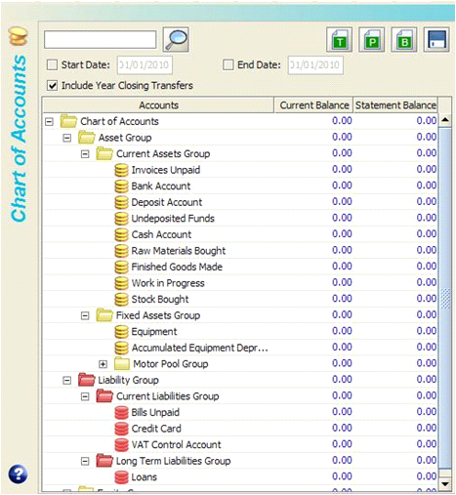

Session 2: P&L
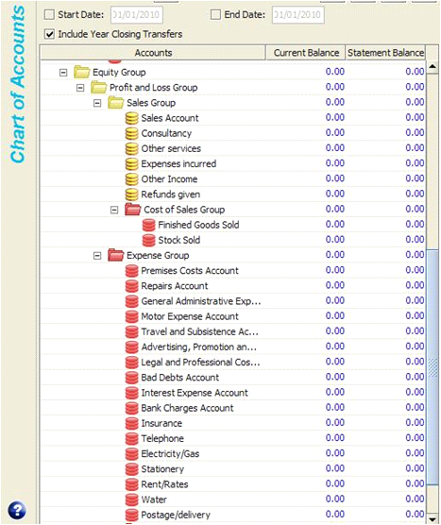

Session 2: Answer to the task
NB for how to add an account see pp.176-178!!!!!
How the Transfer Transaction will appear:
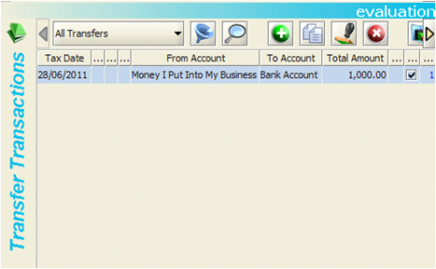

How this will look in the Chart of Accounts:
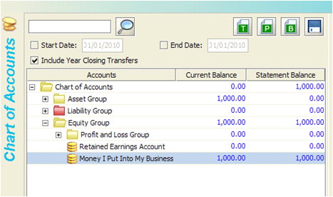

Session 3: Answers to the tasks
Tasks 1, 2 and 3:
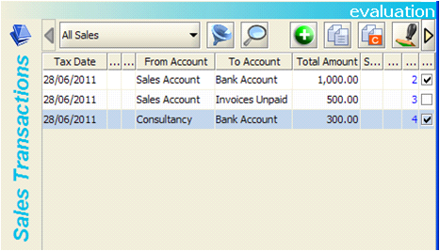

Task 4:
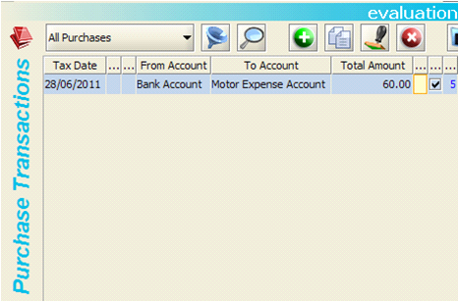

Session 3: Answers to the tasks (cont’d)
Task 5:
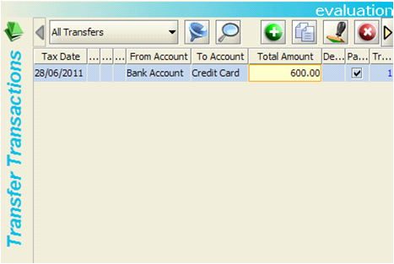

Session 3: Answers to the tasks (cont’d)
How this will look in the Chart of Accounts:
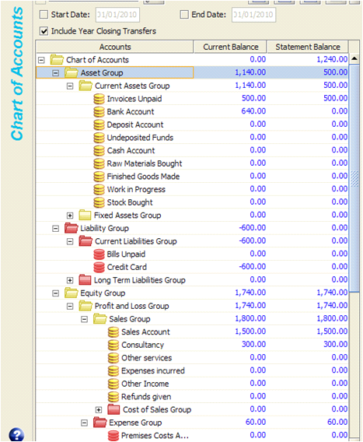

Session 5: Answer to the task
How the Sales Transactions will appear:
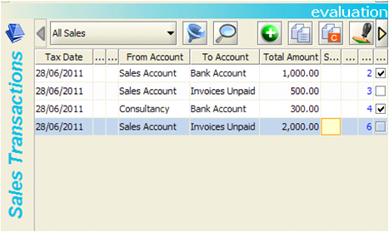

How the Purchase Transactions will appear:
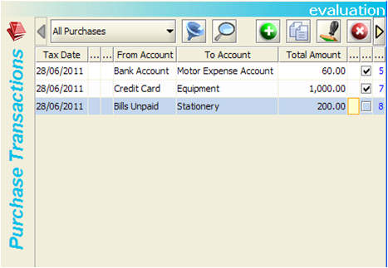

Session 5: Answer to the task (cont’d)
How the Transfer Transactions will appear:
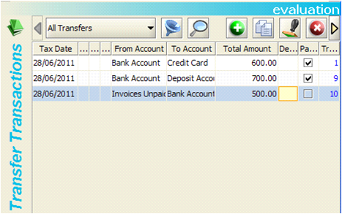

Session 5: Answer to the task (cont’d)
How this will look in the Chart of Accounts:
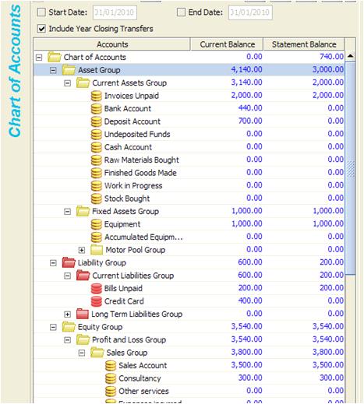

Session 6: Answers to the task
How the Sales Transactions will appear:
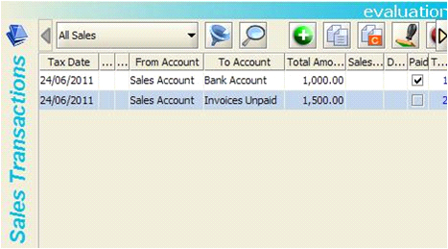

How the Purchase Transactions will appear:
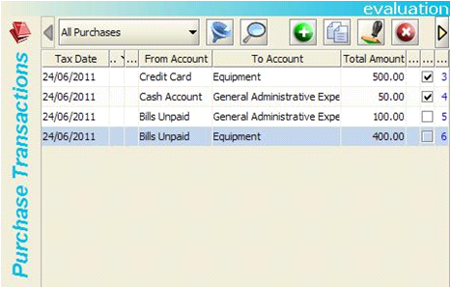

Session 6: Answers to the task (cont’d)
How the Transfer Transactions will appear:
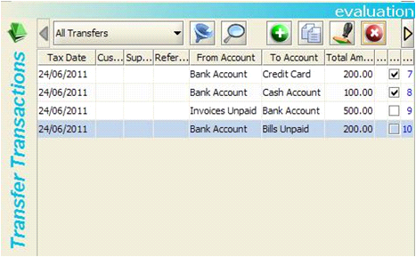

Session 6: Answers to the task (cont’d)
How this will look in the Chart of Accounts:
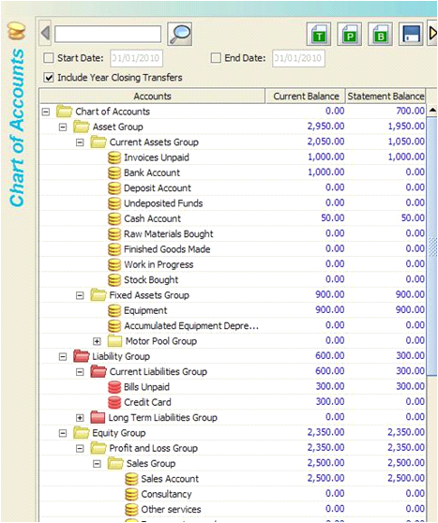

Session 7: Answers to the task
How this will look in the Chart of Accounts:
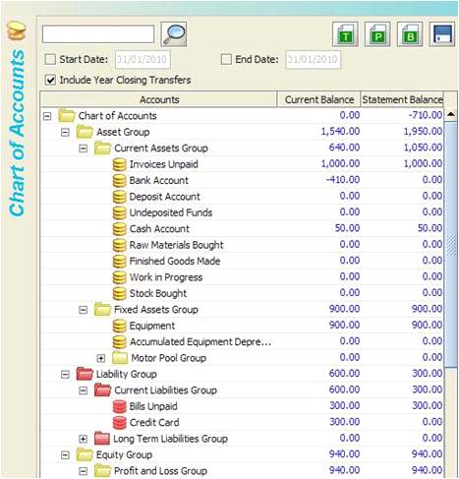

Session 7: Answers to the task (cont’d)
How this will look in the Chart of Accounts:
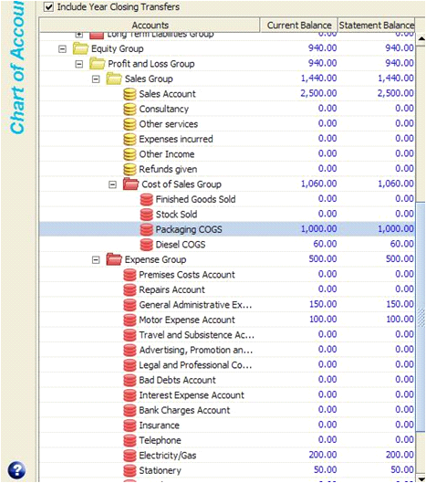

Session 7: Answers to the task (cont’d)
How this will look in the P&L:
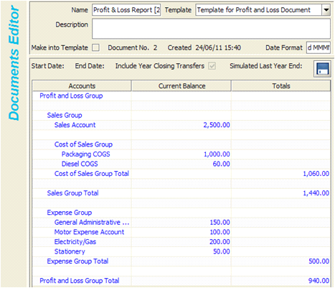

Session 8: Answers to the task
How the Purchase Transactions will appear:
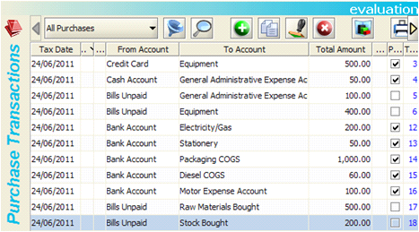

How the Sales Transactions will appear:
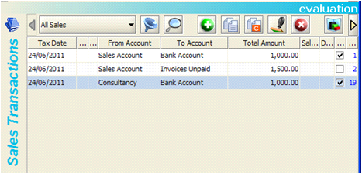

Session 8: Answers to the task (cont’d)
How the Transfer Transactions will appear:
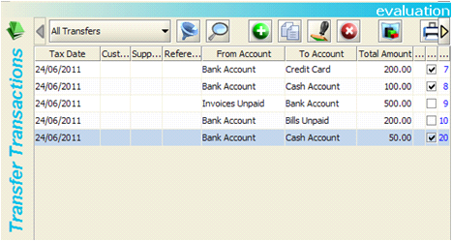

How this will look in the P&L:
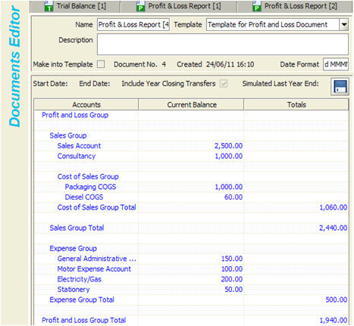

Session 8: Answers to the task (cont’d)
How this will look in the TB:
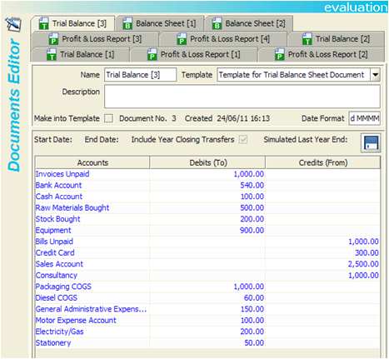

NB This is the view you will get in your trial version. You will notice that the figures differ from those in the TB shown in the course. This is because in the course we show how the figures would look after having done a Year End (you cannot access the Year End feature in the trial version).

Session 9: Answers to the task
NB Finished Goods Sold is the account that is already created in the trial that you can use for the Raw Materials Used account. How the Sales Transactions will appear:
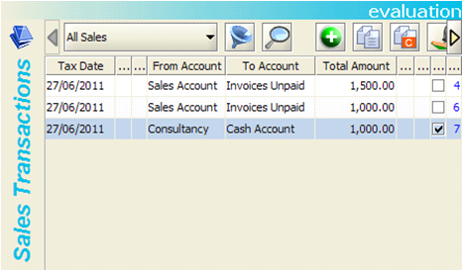

How the Purchase Transactions will appear:
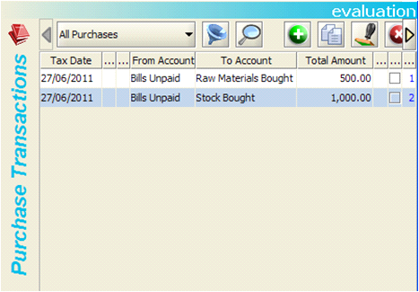

Session 9: Answers to the task (cont’d)
How the Transfer Transactions will appear:
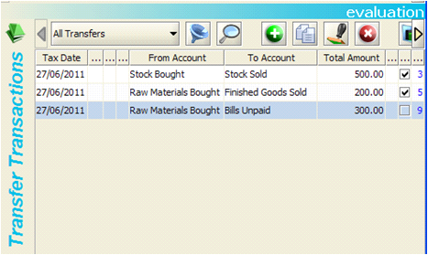

How this will look in the TB:
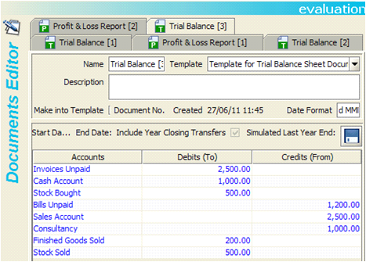

Session 9: Answers to the task (cont’d)
Task 2: How this will look in the P&L:
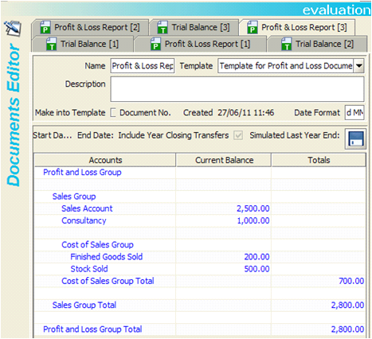

Session 9: Answers to the task (cont’d)
How this will look in the Chart of Accounts:
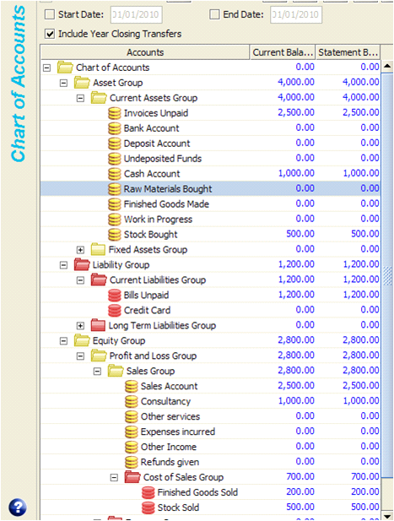

Session 10: Answers to the task
NB You will need to create a new account called ‘Loss on Sale of Assets’ in the expenses group for this task. Here’s how to do it. Double click on the Expense Group in the left hand panel. Click on the Sub-accounts tab on the bottom on the right hand panel. Click on the little green button with a white ‘+’ on it:
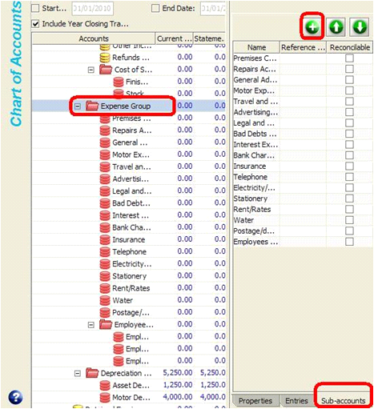

Session 10: Answers to the task (cont’d)
A new window will open like the one below. Type ‘Loss on Sale of Assets’ into the ‘Name’ field. For the ‘Type’ Choose ‘Expense Account’. Click on ‘Yes’ to create the account:
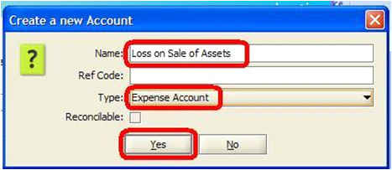

When you have clicked on ‘Yes’ the window will disappear and a new account will now be seen in your Chart of Accounts. However, it is in the ‘Employees’ Group. You will need to move it out and put it alongside the other expenses. To do this you will need to make sure it is selected in the Chart of Accounts by clicking on it so it shows up highlighted in blue as below. Then also click on it in the right hand panel. Then click on the ‘up’ arrow:

Session 10: Answers to the task (cont’d)
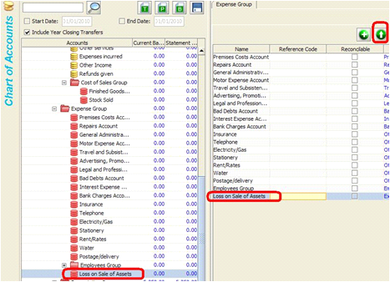

This is the result:
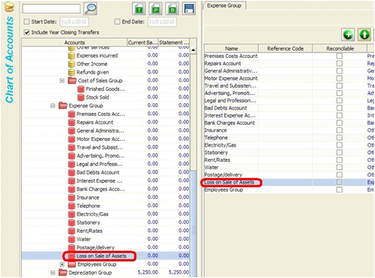

Session 10: Answers to the task (cont’d)
Task 1: How the Purchase Transactions will appear:
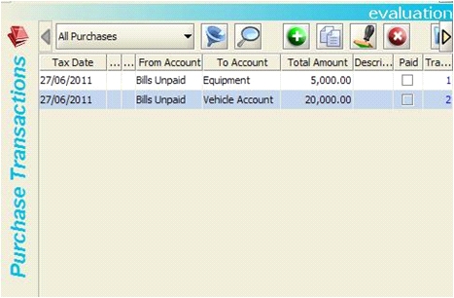

How the Transfer Transactions will appear:
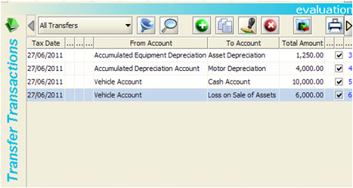

Session 10: Answers to the task (cont’d)
How this will look in the TB:
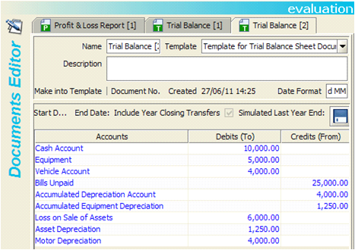

Task 2: How this will look in the P&L:
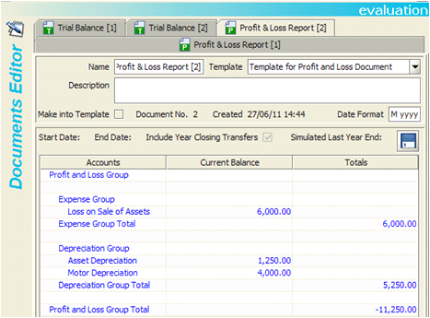

Session 11: Answers to the task
Task 1: NB in our examples here as we using the trial and have chosen the Standard UK VAT rate (as at the time of writing it is 20%). So these answers will differ from those in the main course but they are what you will get in the trial for that rate.
How the Sales Transactions will appear (UK VAT only):
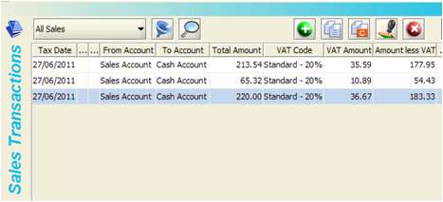

NB We chose some default accounts from the expenses group for demonstration purposes here. How the Purchase Transactions will appear (UK VAT only):
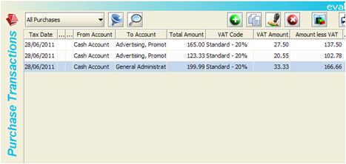

Session 11: Answers to the task (cont’d)
How this will look in the TB (UK VAT only):
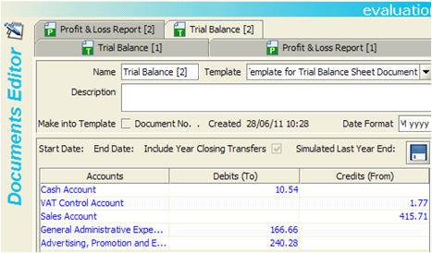

Task 2: How this will look in the P&L (UK VAT only):
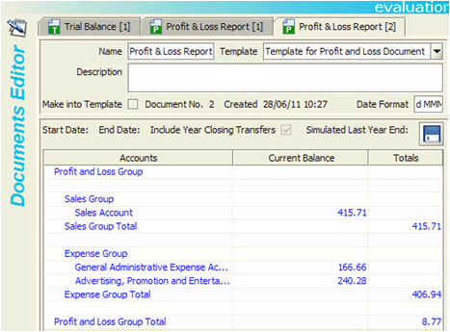

Session 11: Answers to the task (cont’d)
Task 3: How this will look in the Balance Sheet Report (UK VAT only):
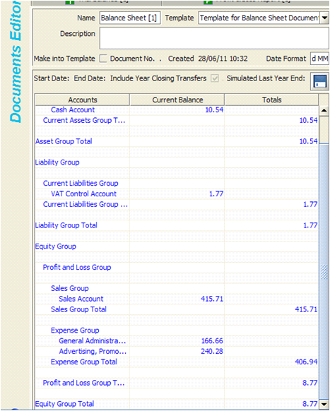

Incomplete Records System (IRS) Trial: Task Answers
Index page
Accounting equation 20
Accounts 8
Accounts payable 48
Accounts receivable 48
Accounts structure 10, 16, 17, 19
ALE 93
Amortization 123
Assets 90
Balance an account 43
Balance B/D 43
Balance C/D 43
Balance sheet 89
Balance sheet layout 93
Balancing stock 121
Chart of accounts 9
Control accounts 142
Cost of goods sold 75
Credit = from 55
Creditors 48
Credits 27
Current assets 91
Current liabilities 92
Debit = to 55
Debits 27
Debtors 48
Depreciation 123
Ebit, ebitda 74
Fixed assets 91
General ledger 35
Gross profit 75
GST 137, 140
Intangible assets 127
Journal 26
Ledger 34
Liabilities 92
Long term liabilities 92
Net profit 76
Nominal ledger 35
Posting 37
Profit and loss 54, 73
Purchase ledger 35
Reducing balance 124
Sales ledger 35
Sales Tax 137, 139
Stock 106
Straight line 124
T account 42
Trading account 87
Transactions 25
Trial balance 46, 52
Turnover 75
VAT 137, 139

